
POPULATION & ITS HIDDEN DIMENSIONS

Lt Gen CA Krishnan, PVSM, UYSM, AVSM (Retd) is a former Deputy Chief of the Army and a former Member of the Armed Forces Tribunal.


It took about 12000 years, from BC 10000 to AD 1800, for the global population to increase from 2.4 million to one billion, but just another 120 years to touch two billion mark by 1920’s. A whopping 6 billion more were added in the next 100 years to reach the present 7.9 billion and we are galloping to add another 2 billion in the coming three decades. The steep population growth witnessed during past century brings forth some relevant questions; can we sustain this growth? Is there a sustainable limit for global population? Are we already across the sustainable limit?

Mahatma Gandhi’s famous quote “The World has enough for everyone’s need, but not enough for everyone’s greed” assumes a different shade in today’s context. Even the great Mahatma may have added far more to his old ‘need’ list, if he were to revisit that list now. Ever increasing global population combined with insatiable human hunger for resource consumption has created a situation where even the present population and its ‘needs’ are beyond what planet earth can support and carry. Over 35% of global population lives in extreme poverty while human intervention continues to cause irreversible environmental destruction. Despite this grim picture, a holistic study of population generally remains a taboo; its close linkages with factors such as region, religion and economic status make discussions on population vulnerable to allegations of being racial and xenophobic.

Asia, the largest continent encompassing about 30% of the global landmass, has the highest population density and carries 60% global population. This ratio is reversed in case of North and South America. Australia remains at an extreme end of the spectrum.

Population: The Asian Bulge
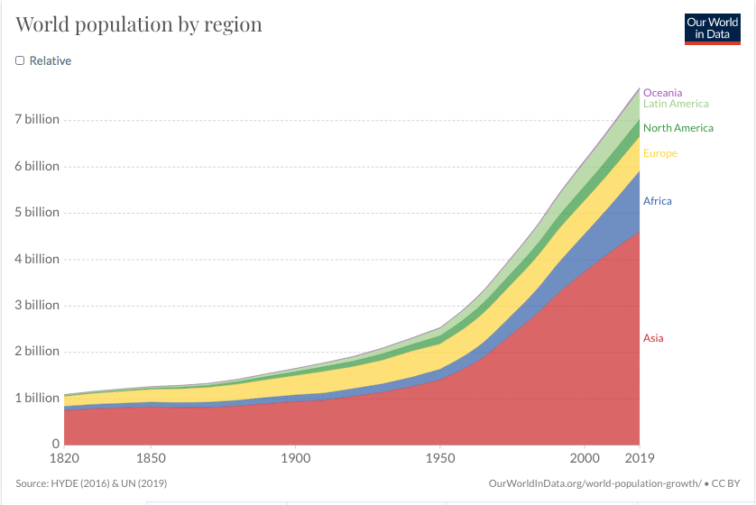

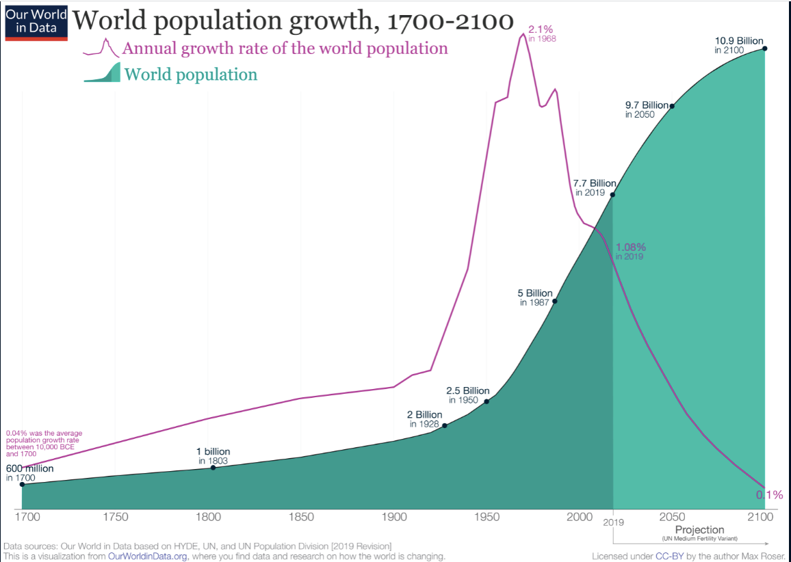
While some researchers’ project scenarios of global population beginning to stabilise by the last decades of this century, the United Nation’s forecast the global population to continue its unabated growth and touch 11 billion by the year 2100.
Unlike the UN projection, Institute of Health Metrics & Evaluation (IHME), an independent global health research centre at the University of Washington, estimates the global population to peak in the year 2064 at about 9.7 billion and thereafter dip to 8.8 billion by 2100. Population growth is a major impediment in achieving sustainable development goals such as eradication of poverty, gender equality, healthcare and education. The irony is that, whether it be the huge numbers, the steep growth % or the unsustainable population density, the problem is most acute in the lesser developed countries. Economic realities, regional & cultural peculiarities and even religious beliefs impact the population growth of a group and also influence its outlook to population control measures. The charts below provide an overview of some of these factors.

Population Growth: Rich Vs Poor
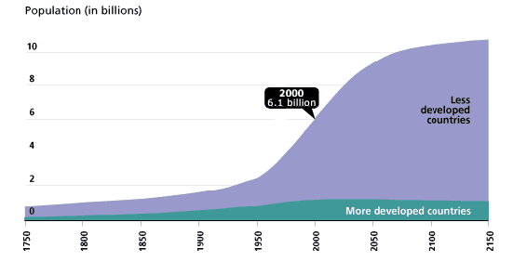

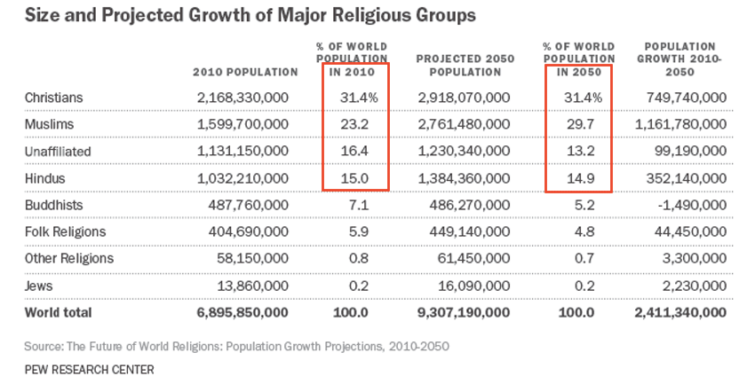
Source: UN, World Population Prospects, The 1998 Revision
Population Growth: Regions/Continents 2019 - 2100 (Source - Statista)
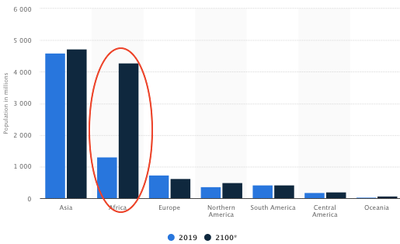

There has been significant drop in Total Fertility Rate (TFR) across the world during the past four to five decades. TFR is the average number of children that would be born to a woman over her lifetime. TFR of 2.1 is considered to be the replacement rate. Average number of children per woman in the world dropped from 5 in 1965 to 3.2 in 1990, to 2.5 in 2019 and is expected to further dip to 2.2 by 2050.

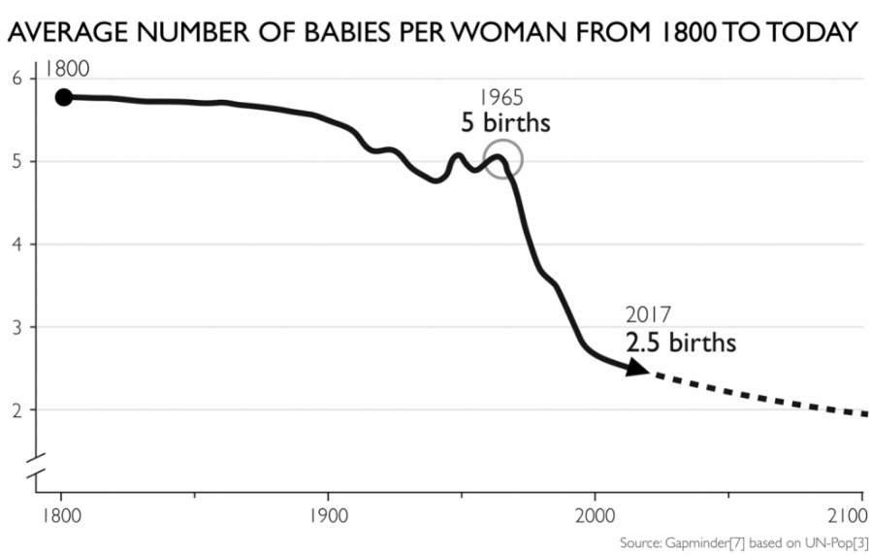

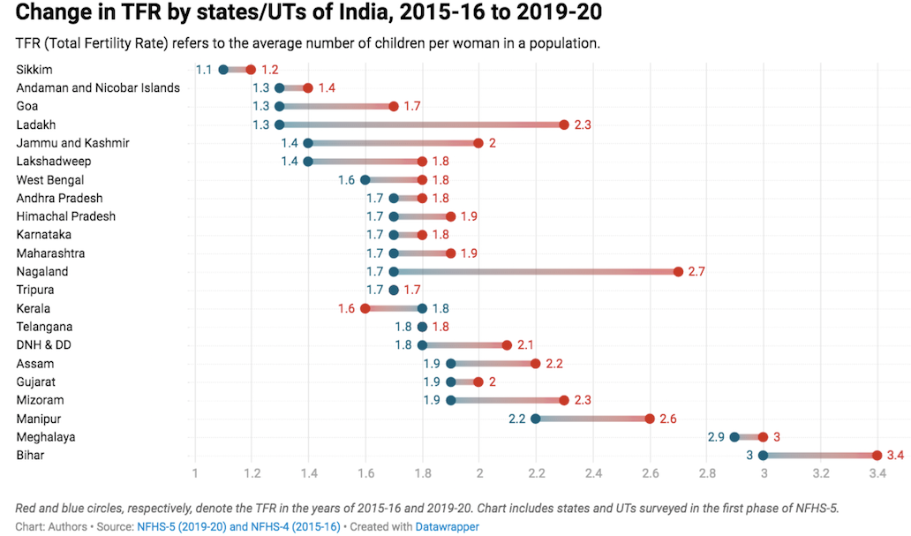
Two major factors that govern population growth are the TFR and the number of women in the reproductive age bracket. Other factors impacting population growth, although to a lesser degree, are infant mortality rate and life expectancy. Although global fertility rate has been reducing steadily and has nearly halved from its 1965 level, the share of women entering reproductive age group has been growing. This is evident from the fact that there were only about 1.6 billion women in the world in 1965 compared to about 3.75 billion in 2020. Thus, even though TFR keeps dropping, population will keep growing for a few decades. Demographers call this phenomena ‘population momentum’. India has made significant progress in terms of TFR in the recent years. In fact, the progress made by some of the Indian states are truly remarkable.

Age structure of population is indicative of the availability of young labour force. When a country’s share of working age population is larger than its non-working age population, it is said to enjoy demographic dividend. A larger percentage of non-working age population, on the other hand, would pose major problems, especially for lesser developed countries. Demographic dividend is a passing phase and with falling TFR, the demographic advantage gradually gets reversed. Lesser developed countries have to harness their ‘demographic dividend phase’ and become developed before the dividend reverses; in other words, a country must become rich before it becomes old. China is an interesting case study. With $10000 per capita Gross National Income (nominal) in 2020, it is still an upper middle income country and some distance short of crossing the $12536 mark to jump into the elite High Income club. As per a Global Times report of May 2021, during the 10 year period 2010-2020, China’s working age population, between ages of 15 & 59, dropped by about 45 million to 894 million, while during the same period the number of people aged above 60 rose from 177.6 million to 264 million. China’s average age now is 38.8 years compared to 38 of US. Clearly, in its endeavour to become rich before becoming old, China has a problem in hand and so it is attempting to shift its economic focus from labour intensive low end manufacturing to digital and hi-tech industries as well as high value-added services like luxury, healthcare and travel. In India’s case, the demographic dividend that it now enjoys would start reversing by 2050 with the average age rising to 35 by 2040 and to 38.1 by 2050. The next two decades are critical for India.

Sustainability level of global population is dictated by two factors; the population numbers and how much the population consumes. While the problem of growing population is peculiar to less developed countries, the problem of unsustainable consumption is unique to the developed world. Population has a direct bearing on environmental degradation, global warming and Climate change. With every passing year, the impact of these are being felt more and more in our daily lives. Annual global Green House Gas emissions, today, stand at about 50 billion tons of Carbon Dioxide Equivalent (CO2e), about 40% higher than what it was in 1990. World also generates more than 2 billion tons of Municipal solid Waste (MSW) annually, which is expected to cross 3 billion tons by 2050; even the oceans and space have not been spared from garbage dumping. The figures are even grimmer, if the total waste generated is considered, which apart from MSW, also includes, Industrial waste, agricultural waste, e waste and hazardous waste. Canada, the biggest total waste producer in the world, generates 1.33 billion Metric Tons (MT) of waste annually, which includes 1.12 billion MT of industrial waste. Canada’s annual per capita waste generation is 36.1 MT, leaving even the US far behind at 25.9 MT. Well-being or ease of living is, to a large extent, equated with developed societies who consume more of every resource. Our measure of ‘degree of development’ of a country is, by default, directly related to consumption which in turn is related to manufacturing, high levels of Green House Gas emissions and waste generation, resulting in developed world’s disproportionate contribution to global warming and climate change.

Even at today’s level, the world population consumes more resources than what the earth can sustainably provide us; we also produce more waste than what planet earth can absorb. ‘Global Footprint’ data shows that, even at today’s levels, to regenerate the renewable resources that we consume and to absorb the waste that we produce, an equivalent of 1.68 planet earth is required. Every day, we are stealing from our grandchildren a bit of their share of the planet’s resources. The richer you are, the more you are stealing. If the current world population were to enjoy a standard of living at par with what Europe has today – which is about 60% that of North America – the earth can sustainably support only about 2 to 3 billion humans on earth. In other words, if the world population stays at the present level and the ‘standard of living’ of lesser developed countries were to rise to the level of today’s Europe, we would require two more planet earths to become sustainable!! A comparison between how much we are consuming today vis-a-vis how much the planet earth can provide us finds clear expression in the ‘Earth Overshoot Day’. ‘Earth Overshoot Day’ in any year marks the date in that year from which we start using more from the nature than what the planet can regenerate in a year. This day has moved from late September in the year 2000 to August 22 in 2020. Shifting pattern of this critical day through last five decades shown in the chart below sums up the shocking story of how human population is ravaging planet Earth. Year 2020, the only exception to the increasing trend in the chart, is a misleading aberration, attributable to the misery brought upon the world by Wuhan virus.
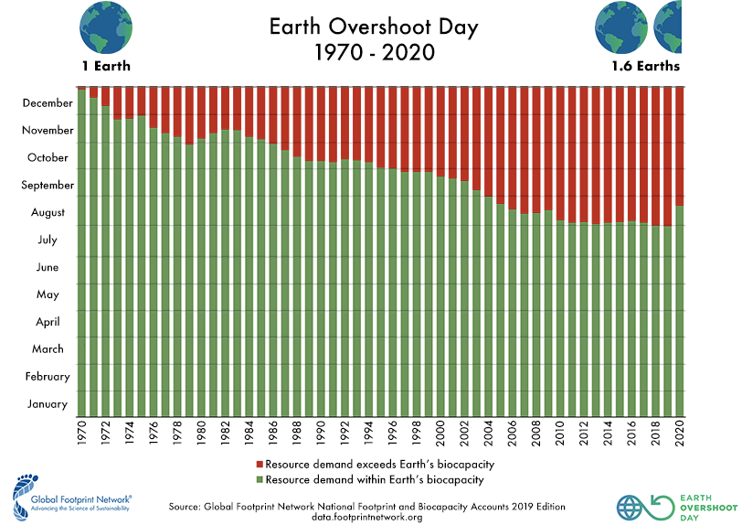

‘Paris Agreement’ negotiated during 21st Conference of Parties (COP 21) which came into force on 4 November 2016, is a significant step towards fighting environmental destruction. As per the Agreement, each country is required to set emission-reduction targets for itself, termed as ‘Intended Nationally Determined Contributions’ (INDC’s). The Agreement has succeeded in encouraging countries to declare their Intended Nationally Determined Contributions depending upon their capabilities, level of development etc; the overall objective being, to limit global temperature rise in this century to below 2 degrees Celsius. While the agreement gives a ray of hope as far as limiting and cutting down levels of green house gas emissions by countries as a whole, the crucial aspect of huge disparities in the per capita consumption, emissions and waste generation between developed and developing countries has not been addressed. The importance of drawing global focus on this issue becomes evident when we consider the mammoth population of the underdeveloped world and their genuine and justifiable development aspirations in the backdrop of the yawning gap in their standard of living. While the developed world cannot be held responsible for the huge population and its continuing growth in lesser developed countries, they are definitely responsible, through their unsustainable consumption, for the degraded state of planet earth today. In the larger interest of the world, therefore, both sides need to show sensitivity to the position of the other side while addressing their part of the problem. It is also a fact that the much touted, resource saving and environment friendly green technologies on which the world’s hopes for sustainable growth are pinned, are almost entirely in the hands of the developed world and generally beyond the economic reach of poorer nations. Glaring disparities in GDP, consumption, emissions and waste generation between the two worlds are evident from the charts below.

Disparity: Per Capita GDP, Consumption & Emissions
Country | % of world population | GDP (Nominal) $ Trillion (World Bank) | Per Capita GDP(Nominal)$ (World Bank) | % of global emissions | Per Capita Emissions in Metric Tons (World Bank) | % of Global MSW Generated | Per Capita MSW generated (kg/day)# | Per capita energy consumption (Giga-joules)
USA | 4 | 21.43 | 65297 | 14.6 | 15.5 | 12 | 2.24 | 287
China | 18 | 14.34 | 10216 | 27.2 | 7.2 | 15 | 0.43 | 98
India | 18 | 2.87 | 2099 | 6.8 | 1.8 | 12 | 0.57 | 25
Brazil | 3 | 1.83 | 8717 | 1.3 | 2.2 | 4 | 1.04 | 58
Russia | 2 | 1.7 | 11585 | 4.7 | 12 | 3 | 1.1 | 204
Germany | 1 | 3.86 | 46467 | 2.2 | 8.8 | 2 | 2.11 | 157
Japan | 2 | 5.08 | 40249 | 3.3 | 8.9 | 2 | 0.95 | 147
Australia | 0.5 | 1.4 | 55057 | 1 | 15.5 | 1 | 1.54 | 254
UK | 1 | 2.83 | 42328 | 1 | 5.8 | 2 | 1.33 | 116
Canada | 0.48 | 1.74 | 46189 | 1.6 | 15.1 | 2 | 1.94 | 379

# MSW does not include industrial waste, e waste, hazardous waste and agriculture waste. With these included, Canada is the biggest waste producer in the world producing 1.33 billion MT waste annually.
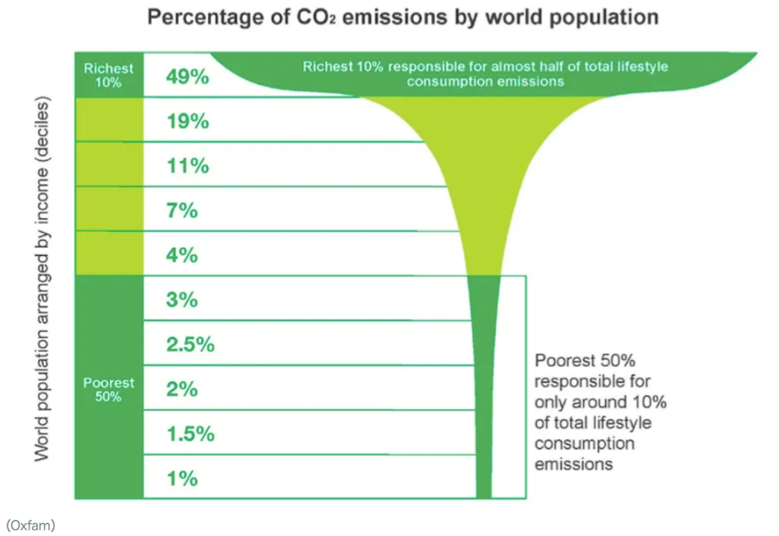

In the backdrop of the enormity of the problem, measures such as Paris Agreement’s ‘Nationally Determined Contributions’, although well intended, are grossly inadequate. It is also a fact that decoupling aspirations of lesser developed countries from resource extraction and environmental destruction is impossible. As per Brian Wang of nextbignews.com, a leading science news blog, population of developed world today stands at 1.3 billion, about 17% of world population. China, Mexico, Turkey and Thailand are expected to join this fold by 2030 to make it 35%; India and Vietnam are on track to make the cut by 2040, and by 2050 most Asian countries are also likely to join this group to take the developed world’s population tally to 50%. That gives a glimpse of the stupendous rise anticipated in the world’s appetite for resources in the coming two to three decades. The world is being pushed to a tipping point. Unfortunately, despite the pivotal role of population in this relentless environmental destruction, any open discussion and targeted efforts to check population becomes politically suicidal and is considered morally inappropriate. Forced population control measures which trample over sensitivities of communities can be counterproductive as was demonstrated in India in the seventies. Population control measures also have long gestation period and take more than a generation’s life span before its impact gets translated into outcomes on ground. With agencies such as IHME forecasting its population to half to about 730 million by 2100, China finds its one child policy an inappropriate holistic solution to the complex dimensions of population problem. Population issue is far more than just the numbers or growth percentage. Past experience indicate that to find acceptability across regional, religious, national, cultural and economic taboos, measures to control population must target ‘uplifting of societies’ as their primary objective, with population control only an indirect, but significant, spin off beneficiary. A case in point is female education and women empowerment, a measure found to be most effective and readily acceptable across most communities.

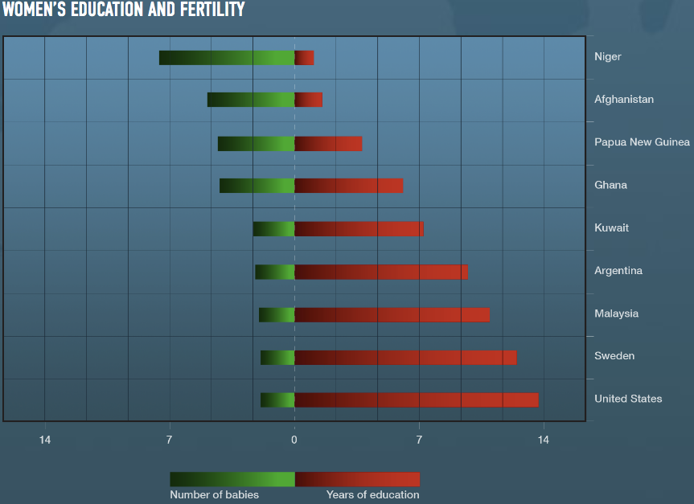
Other measures to achieve population control through programs targeting uplifting societies include improving the health infrastructure, reducing income disparity, higher literacy levels and creating general awareness about benefits of smaller but healthier families and empowered population. Concerted efforts are required in lesser developed countries to identify and adopt policies aimed at removing real as well as perceived economic and social risks of having small families.
Unsustainable population growth in any part of the globe would spell trouble for the entire world; developed countries will be overwhelmed by mass migration into their borders, creating social upheaval. Lesser developed countries require generous technological and financial assistance to achieve sustainable population growth and adopt a sustainable development model. In addition, developed countries on their part, must also set a trend by drastically cutting down their hugely disproportionate per capita consumption and emissions. Time is running out. The dangerous mix of population growth and resource consumption is on a collision path with planet earth, threatening the well being and survival of the entire human race. A united global approach is the only solution to this complex problem with its numerous dimensions.

CERTIFICATE

The paper is author’s individual scholastic articulation. The author certifies that the article is original in content, unpublished and it has not been submitted for publication/web upload elsewhere and that the facts and figures quoted are duly referenced, as needed and are believed to be correct..

Disclaimer: Views expressed are of the author and do not necessarily reflect the views of CENJOWS.

