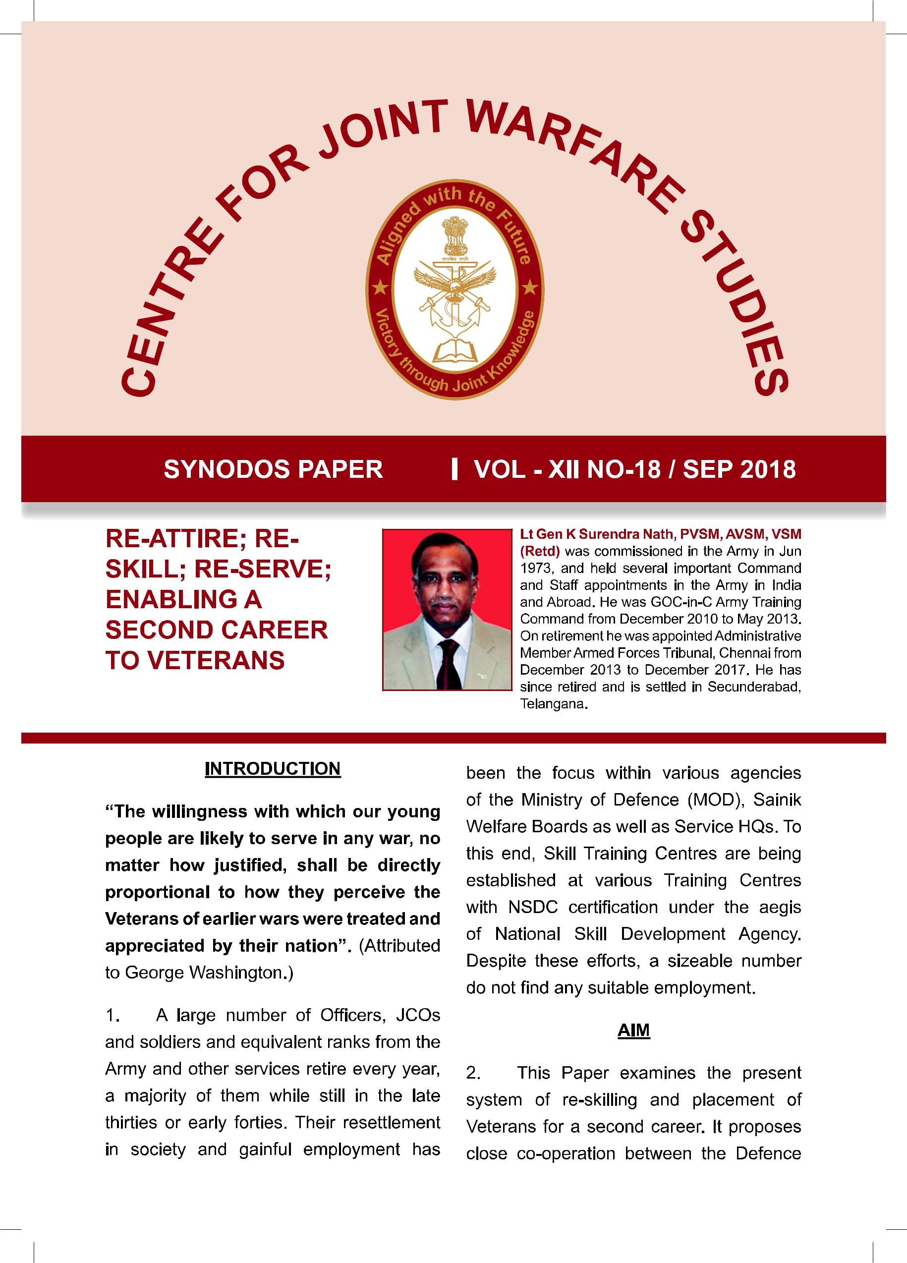

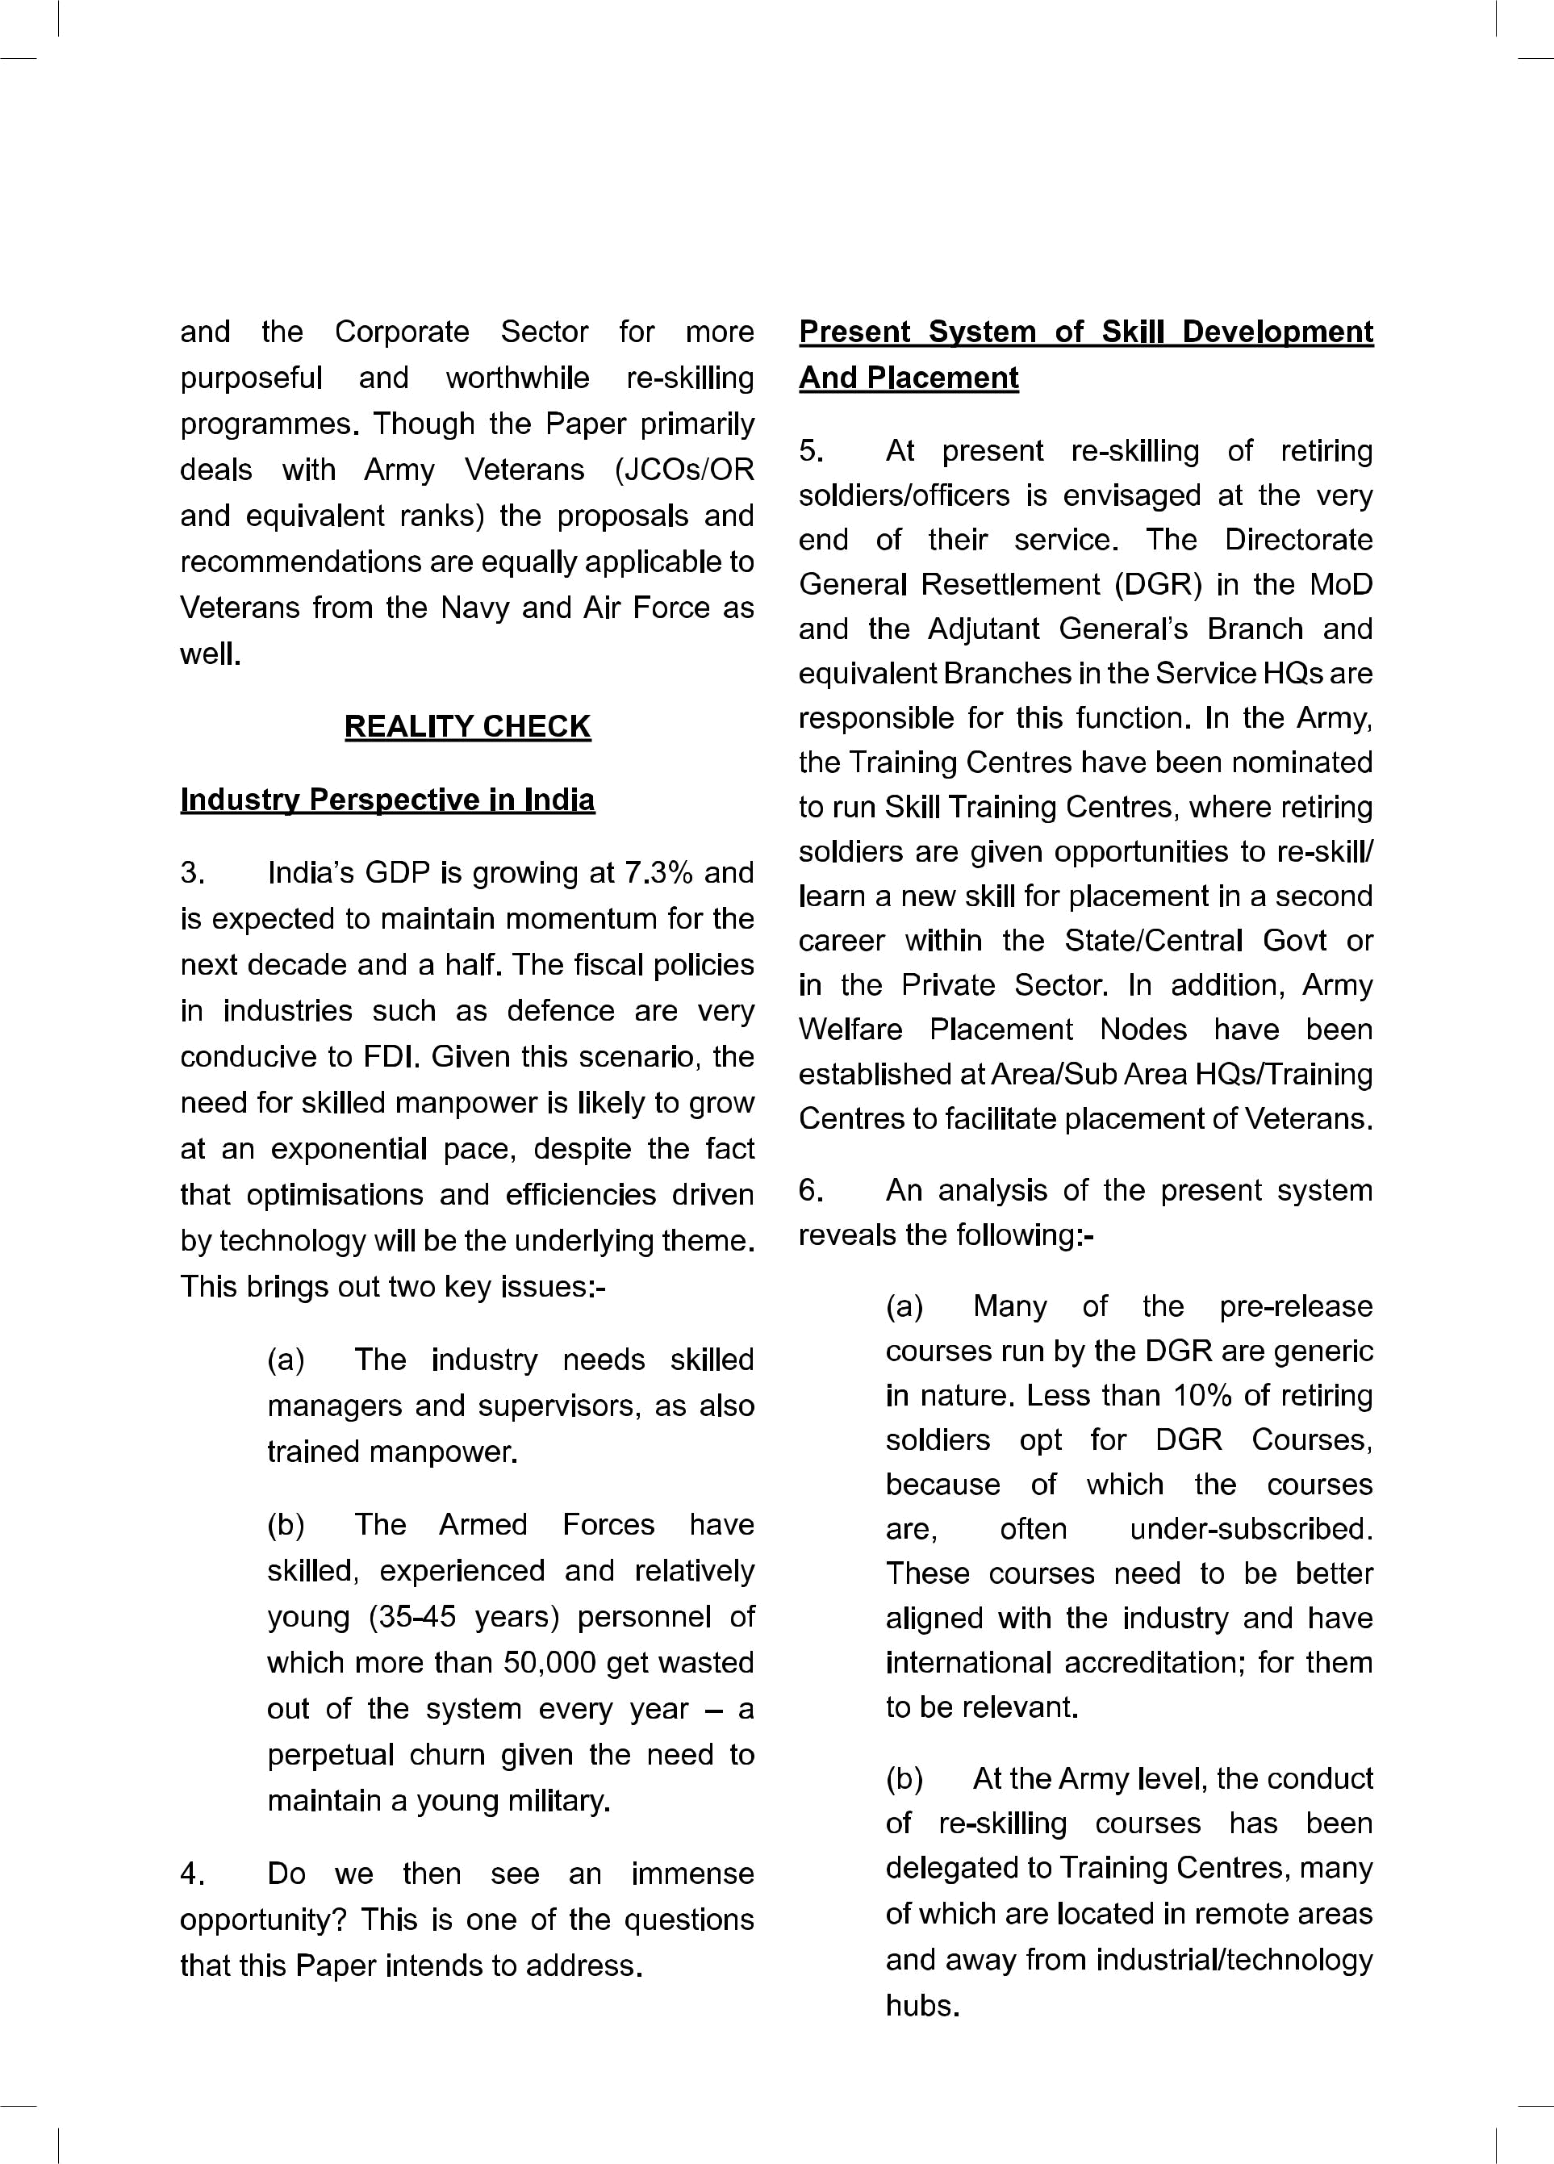

- The primary task of the Training Centres is recruitment and in service training. Running Skill Training Centres is an added burden on Training Centres with little or no expertise or accretion to their manpower.

- There is little involvement of regional Commands and static formations such as Area and Sub Area in Skill Development, as this is centrally controlled by the Service HQs.

- Presently, most of the courses conducted at Skill Training Centres are in the nature of “bridging courses”. These are short courses ranging from five to 15 days in duration and outsourced to Private Agencies. Their primary objective is to provide NSDC Certification for an already acquired military skill such as Welder, Lab Technician, Chauffer, etc, rather than learning a new skill. Furthermore, the focus appears to be on Skill Certification alone, rather than placement for jobs, which is equally essential.

(f) In the Army, there is little synergy between the Army Veterans Cells, the Placement Cells and the Army Welfare Placement Organization (AWPO) at the functional level, even though at many places they are co-located.
CENJOWS  3



Similarly there is little or no coordination between DGR and similar placement organizations at the Service HQs.

  - The Veterans.

    - Veterans mostly prefer jobs close to their home and are reluctant to relocate for taking up employment which entails separation from their families.

    - They prefer jobs in Central/State Govt. Such jobs are limited in number, and are mostly taken by the more qualified personnel from Air

Force, Navy and technical Arms and Services within the Army. Soldiers from Combat Arms, of the Army especially from Infantry, find themselves insufficiently qualified for such jobs. Poor English communication and IT Skills are the major constraints.

    - There are limited job opportunities in rural areas.

- Recently, a Veterans Seminar was conducted at Mumbai under the aegis of HQ Maharashtra, Gujarat and Goa Area. The Seminar was well represented by senior members of the Corporate Sector, Philanthropists and NGOs, Veterans, widows and dependents. The Seminar
- CENJOWS


threw up some interesting issues. It was evident that there is a mismatch of skills and aspirations of the Veterans vis-a-vis what the private industry is looking for. Further, the Veterans’ needs across rank (officers/JCOs/OR) and Services (Army, Navy and Air force) are different and need to be categorised accordingly. Some of the issues that came up were:-

- Poor understanding of the recruiters with regard to Military Skills and their appropriate equivalence in Civil.

- Poor communication skills and lack of re-orientation to civilian/ corporate culture.

- High expectations of Veterans without matching potential.

- Demanding pay and allowances commensurate to previous rank in service.

- Rigid hierarchical approach in dealing with peers and subordinates.

- Skills acquired do not match industry’s requirements.

- Lexicon used in the corporate world does not align with that used in the military.

- There is little or no understanding of handling budgets and financial statements.

- Isolation of the military and lack of currency of technology across all functions.

- Lack of preparation and seriousness to embark on a second career leading to an expectations gap.

- Lack of accredited certifications.

- Lack of financial guidance, family relocation, children education and related issues.

US Experience in Skilling and Providing Second Career to Veterans

- It is instructive to study the American experience in skilling and providing a second career to their Veterans. Re-skilling and employment of veterans has been a major issue in the US, since World War II. A large number of soldiers were demobilized at the end of the war leading to the landmark enactment of the Servicemen Readjustment Act of 1944

(GI Bill). The benefits included dedicated payment of High School/College tuition fees including living expenses; payment of fees for technical/vocational training; low cost mortgages for house building and low interest loans to start a business. They were also given unemployment monetary compensation for a period of one year. The programmes were hugely successful and by 1956 a majority of the War Veterans were able to pursue second career opportunities. The Act has seen

several amendments since its enactment, but continues to be relevant in dealing with Veterans education programmes to this day. In the last few decades, skilling and providing jobs to Veterans has once again received considerable attention, especially with the active commitment of US Armed Forces in the Gulf, Afghanistan and elsewhere. Usually, the US Soldiers are recruited on short periods of engagement (typically from 4 to 10 years of service) and therefore are discharged from service at a relatively young age, with appropriate but no long term pensioner benefits. However, a large number volunteer to join the Armed Forces, as it provides them good service conditions and remuneration; as well as high status in society, apart from post discharge benefits. On their discharge from service, the US Government, Private Sector as well as a number of Charitable Foundations actively assist them in facilitating their academic advancement and second career opportunities. This commitment is exemplified by what former President Obama said, “No veteran who fought for our Nation should have to fight for a job when they come home”. To this end, they publicise, promote and conduct Veterans Career Transition Programmes. Much like us, they find that providing jobs to the Veterans is often difficult on account of perceived skill mismatch, employer discrimination, adjusting to corporate work culture and lack of job security, amongst others. Large Corporates and

private industry were incorporated to find
CENJOWS 5

solutions to these issues. In 2011, JP Morgan Chase & Company aligned with ten other major companies to establish the “100,000 Jobs Mission” with the object of providing 100,000 jobs to Veterans by 2020 through suitable re-skilling programmes. The idea spread rapidly and the number of companies forming the “coalition” increased to 175 companies and they were able to provide more than 200,000 jobs by 2014 itself. In turn, the US Govt has given Businesses tax concessions for hiring eligible unemployed Veterans known as “Work Opportunity Tax Credit (WOTC) and Wounded Warriors Tax Credit for hiring Veterans with service connected disabilities. Over the years, the US Government in collaboration with industry and other Non-Government Organisations (NGOs) has established well tailored programmes known as “Primary Veteran Employment and Training Programmes”, with a commitment from CEOs of major companies undertaking to hire them after suitably re-skilling them. Some of the reskilling programmes conducted by the companies extend upto six months duration. The Trump Administration has since passed the Veterans Educational Assistance Act, 2017 (Forever GI Act) significantly enhancing and removing limits on benefits for veterans, service personnel, families and dependents. Similar programmes have been adopted in Canada, UK and Australia amongst other countries.
- CENJOWS

PARTICIPATING IN INDIA’S

GROWTH STORY

Re-attire; Re-Skill; Re-Serve

- The Armed Forces Veterans possess unique and specialized skills. They are perseverant, creative and mouldable, with vast experience in working for prolonged hours under adverse conditions. They have good leadership, administrative and management skills. These attributes can be exploited in preparing them for a second career as productive members of society and to participate in India growth story. Conceptually, this transition should be done in three seamless phases:-

  - Re-attire. When a Soldier after long years of disciplined and orderly service, retires and transits into a less organized and somewhat “laissez faire” environment, he is bound to face initial difficulties. He should be prepared for social and attitudinal adjustments. It would be appropriate if the Training Centres run a two week capsule on “Transition Management”, as a part of his “Pension Drill”. Varied subjects such as awareness of veteran benefits including for dependents, financial planning, CSD, ECHS and extended AGIF benefits, military skills and civil skill equivalence, entrepreneur skills, CV preparation, corporate work culture and ethics, AFT Act and Armed Forces

Tribunals, psychological orientation and counselling etc may be included. Assistance of private agencies/ NGOs in conducting a part of this training, especially on aspects of corporate culture, entrepreneurship and financial management, could be considered.

(b) Re-skill. The second aspect is to match/align his military skills with civil skills and also provide him fresh skills based on his aptitude and interest. Such re-skilling programmes should be identified and put in place well in advance and as a benchmark at least one year prior to his eventual discharge/ retirement.

- Re-serve. Finding him a placement based on his Knowledge, Skill and Ability (KSA) within Government/Private Industry. This would require a concerted effort, firstly in preparing his CV, identifying and matching his military skills/newly acquired skills to jobs in the Private/ Public Sector and improving his communication skills as preparation for job interviews.

The Way Forward

- Given the articulation above, we could look at finding a pragmatic way to exploit this opportunity at three key levels:-

- Strategic/Apex Level:-

  - A detailed policy to be evolved at the Ministry of Defence (MoD) to support the second career settlement of veterans.

  - A MoU be signed between the MoD and
participating corporate companies. The Government may consider according them ‘Indian Military Friendly Company’ status. The CII and FICCI could be involved in outreach.

  - A study group of veterans/experts with relevant corporate experience be formed to develop a five year action plan. This Study could be piloted by an appropriate agency in HQ Integrated Defence Staff (IDS), on behalf of Ministry of Defence (MoD).

- Operational/Regional Level:-

  - An industry outreach programme to be launched by Service HQ/IDS to reach out to industries and understand needs of sectors that best align with us and evolve ‘Skill Bridge’ programmes.
CENJOWS 7

  - A suitable/appropriate interning opportunity with the industry prior to retirement to be considered.

  - A ‘Hire & Train’/’Skill and Hire’ opportunity be explored with the participating companies from the corporate.

- Field Level:-

  - Skilling programmes at Training Centres for retirees be immediately reviewed and aligned with participating companies.

  - Basic soft skills such as English language communication, computer skills (MS Word, MS Excel and MS Outlook), working in a non-regimented environment and lexicon training must be encouraged about 12 to 18 months prior to retirement.

This preparation for separation would have to be led by the Training Centres/ Formation/Station IT Training Schools guided by Branches dealing with Veterans Affairs in Service HQs.

Recommended Approach

- It is obvious that any effort in re-skilling Veterans and providing them
- CENJOWS

with employment would require major involvement and support of the Corporate/ Private industries in our Country. Under the provisions of the Companies Act (Section 35, Schedule VII) read with GSR 103 (t) dated 27-02-2014, funds earmarked for Corporate Social Responsibility (CSR) can be used for measures for the “benefit of Armed Forces Veterans, War widows and dependents”. The CSR funds can also be contributed towards a corpus of a Trust/ Society/Section 8 Companies etc that are created exclusively for undertaking CSR activities. Presently Corporates/ Private companies are contributing a part of their CSR funds directly to the National Skill Development Agency, of which only a meagre share is trickling down for Skill Development within the Armed Forces. We have a sizeable number of companies/ industries, including PSUs involved in defence manufacturing. Ideally, their CSR contributions should facilitate re-skilling of Veterans and thereafter providing them suitable employment.

- In our country, most of the industry/technology hubs which provide opportunities for skilled and semi skilled workers are located in major cities, such as Mumbai, Pune, Delhi, Bangalore, Chennai, Hyderabad, Kolkata etc. Our Area/Sub Area HQs that look after Veterans Affairs at functional level are also co-located in these cities. It would, therefore, be more beneficial and fruitful if our Skill Training

Centres are located within these cities

and function under the aegis and control of HQs Area/Sub Area. Such Skill Training Centres could be established on surplus Defence Lands (‘B’ Category) and run with the help of the industry, who will provide the technical expertise and instructional staff. This would also facilitate our retiring soldiers/Veterans to do an internship with sponsoring companies, enabling them to align and hone their technical skills, as well as get a feel of corporate ethos and work culture. A functional and productive partnership between the Armed Forces and the Corporates/industry for skill development and eventual placement is the way forward, if we are to re-skill and find employment for our Veterans, widows and their dependents on a large scale.

- Further, the following issues merit consideration:-

  - Clubbing of a large number of Skill Training Centres under one roof, would be both cost-effective and efficient from the point of view of administration, management and eventual placement. This concept has also been envisaged in the NSDA mission document in the form of Multi Skilling Institutes on a Public-Private Participation model (PPP).

  - A large number of Veterans look for employment close to their home.

  - Due to limited technical skills and educational qualification, as well

as stiff competition, many of them do not get suitable placements within the industry/private sector.

- A significant portion of re-skilling courses should, therefore, focus on jobs that provide for self-employment. These may include automotive driving and maintenance, air-conditioning, plumbing, electrical works, logistics management, mobile repair, horticulture, modern farming techniques etc.

- In order to encourage self-employment, the Government of India’s ‘Mudra Yojna Loans’ may be provided at concessional rates to Veterans, enabling them to meet initial establishment costs.

Defence-Corporate Partnership for Skill Development

14. The recommended Defence– Corporate Partnership for Skill Development may be based on the model of Multi Skill Training Institutes (MSTI), as envisaged in the Finance Budget for the year 2016-17:-

- Skill Development Hubs. Establishment of Skill Development Hubs (SDH) /MSTI on Defence Lands with a combination of Government and CSR Funds in the proximity of cities/towns which are industrial/technology centres should be considered, on priority. These should preferably be located in the
CENJOWS 9

proximity of Sub Area/Area HQs on Defence Lands and under the functional control of such HQs.

- Skill Training Sub- Centres. A typical hub could contain 15-20 Skill Training Sub-Centres with separate residential and messing facilities for Veterans, widows and Dependents. Each hub should have a capacity to train upto 500 Veterans/ Widows /Dependents at a time. The focus should be on providing new skills, which would require training for a period ranging from six weeks to 12 weeks. It is estimated that approximately 2500-3000 persons can be trained in a year, at each hub.

(c) Regional Spread. The

Skilling Hubs should geographically be spread across the country, with each region having two to three hubs, depending on demand and veteran population. This would provide easy access for attending courses after retirement. This would also be convenient for widows and dependents to undertake such training.

- Course Content. Course content at the Skill Training Centres should be aligned to the skills that enable their smooth absorption by the industry locally. Therefore, the training programmes should have adequate flexibility to meet
10 CENJOWS

the needs of NSDC accreditation as well as aligning with corporate requirements.

- Land and Capital Outlay. A Skill Development Hub would require approximately 5 to 6 Acres of land and an initial capital outlay of Rs 20-25 crores. Further, a recurring expenditure of Rs 2-3 crore per year should be catered for.

- Subscription to Courses. Ideally, soldiers and equivalent may be permitted to attend one of these courses, within the last year of their service. Further, Veterans may also be permitted to attend these courses, within five years from the date of discharge. This is only suggestive, and suitable rules with adequate flexibility may be framed.

- Widows/NOK of Deceased Soldiers/Dependents. A portion of courses and facilities should cater for widows and dependents. The courses identified could be both technical oriented as well as soft skills such as IT related, Fashion Designing, Hospitality Industry etc.

- Management. Skill Development Hub should be controlled, supervised and managed under the aegis of Area/Sub Area HQs. However, functional management could be vested in

the hands of Veterans. While the initial Instructional Staff may be provided by the industry, it should be the endeavour to replace them with suitably qualified and trained veterans, in due course.

- Funding. A flexible model is recommended. The funding could be either through funds budgeted to the Ministry of Skill Development and Entrepreneurship or a Corpus may be created within the MoD, to which the corporate companies, philanthropists, individuals and NGOs, may donate. In addition, the Central Government may also contribute as part of budget allocation for the training of ESM. Further, Army Group Insurance Fund (and similar organisations) may contribute their CSR funds. Contributions from Welfare Funds of Service HQ, Command/Area/Sub Areas should be considered to further augment the Corpus. Funds from the Corpus may be utilized for building the infrastructure, running courses and other administrative expenses. Some of the companies/ donors may wish to provide equipment and instructional staff for a particular skill, which is aligned to their own industry. Such contributions in kind may also be accepted and appropriate MOUs signed with the industry/corporate companies.

 |  |  |  |  |  |  |  |  |  |  |  | CENJOWS |  |  |  |  |  | 11
(k) | Companies / PSU Banks etc |  |  |  |  |  |  |  |  |  |  | placement and in some cases it is
may also be requested to sponsor |  |  |  |  |  |  |  |  |  |  |  | as high as 90%.
each | of the |  |  | Skill |  | Training |  |  | Centres |  | 15. | Miscellaneous Issues
either singly or in partnership. This |  |  |  |  |  |  |  |  |  |  | 15.
could include the following:- |  |  |  |  |  |  |  |  |  |  |  | (a) | Matching |  |  | and | Aligning of
 | (i) |  | Technical equipment. |  |  |  |  |  |  |  |  | Military Skills with Civil Skills. |  |  |  |  |  |  | A
 |  |  |  |  |  |  |  |  |  |  |  | concerted effort needs to be made
 | (ii) |  | Instructional Staff. |  |  |  |  |  |  |  |  | to align Military Skills including
 | (iii) |  | Providing |  |  |  |  | a | suitable |  |  | qualifications attained during service
 |  |  |  |  |  |  |  |  |  |  |  | with | equivalent |  |  | Civil | Skills, as a
 | Internship Programme as part
 |  |  |  |  |  |  |  |  |  |  |  | means of communicating to potential
 | of the training.
 |  |  |  |  |  |  |  |  |  |  |  | employers. DG |  |  |  | Resettlement |  |  | has
 | (iv) |  | Funding |  |  |  |  |  | towards |  |  | prepared a Manual on Equivalence
 | administrative expenses such |  |  |  |  |  |  |  |  |  |  | of Military Trades and Civil Trades in
 | as boarding and lodging |  |  |  |  |  |  |  |  | etc. |  | 2012. The Manual appears to have
(l) | Possible |  |  |  |  | Model. |  |  | Several |  |  | been prepared to assist Employment
(l) |  |  |  |  |  |  |  |  |  |  |  | Officers. It is not clear if Service HQs
Philanthropists |  |  |  |  | are |  | running |  |  | Skill |  | or Corporates have been consulted,
Training |  |  | Centres |  |  | in | the Country.
 |  |  |  |  |  |  |  |  |  |  |  | whilst |  | preparing |  | the Manual. The
Usually |  |  | these |  |  | are |  | funded |  | by
 |  |  |  |  |  | are |  |  |  | by |  | Manual is |  |  | generic in |  | nature |  | and
Charitable Trusts and through CSR
 |  |  |  |  |  |  |  |  |  |  |  | does |  | not | give | equivalence |  |  | for
funds. |  | A | typical |  |  | example |  |  | is | the |  | does
 |  |  |  |  |  |  |  |  |  |  |  | qualification attained during service.
Swarna |  | Bharat |  |  |  | Trust |  | which |  | has
 |  |  |  |  |  |  |  |  |  | has |  | The Guide for Army Trades lists
established three |  |  |  |  |  | such |  | Centres in
 |  |  |  |  |  |  |  |  |  |  |  | out suitability of employment for
Hyderabad in Telangana and Nellore
 |  |  |  |  |  |  |  |  |  |  |  | each | Trade in order |  |  |  | of | priority,
and Vijayawada in Andhra Pradesh.
 |  |  |  |  |  |  |  |  |  |  |  | based on job content, nature, type
Several |  | skill |  | disciplines |  |  |  | with hostel
 |  |  |  |  |  |  |  |  |  |  |  | and length of training, education
and | messing |  |  | facilities |  |  |  | are | located
 |  |  |  |  |  |  |  |  |  |  |  | and |  | technical |  | qualifications,
within |  | a | single |  |  | campus. |  |  | Food, |  |  | and
 |  |  |  |  |  |  |  |  |  |  |  | suitability |  |  | and | aspirations |  |  | etc.
accommodation and training for the
 |  |  |  |  |  |  |  |  |  |  |  | For example, an Infantry Soldier’s
students are completely free. Further,
 |  |  |  |  |  |  |  |  |  |  |  | training is |  |  | listed as 19 |  |  | weeks
the sponsoring companies provide
 |  |  |  |  |  |  |  |  |  |  |  | and | civil trade |  |  | equivalence |  |  | as
technical equipment and instructional
 |  |  |  |  |  |  |  |  |  |  |  | Wine |  | Waiter, Bearer Domestic,
staff and some companies enable |  |  |  |  |  |  |  |  |  |  |  | Wine
 |  |  |  |  |  |  |  |  |  |  |  | Transport |  |  | Service |  | Operator,
the students to do internship in their
 |  |  |  |  |  |  |  |  |  |  |  | Watchman, |  |  | Sepoy |  | Customs,
factories/technology |  |  |  |  |  |  | centres. |  |  | This
 |  |  |  |  |  |  |  |  |  | This |  | Forest |  | Guard, |  | Peon, |  | Cleaner
has | resulted |  |  | in | a high degree of
 |  |  |  |  |  |  |  |  |  |  |  | Motor |  | Vehicle, |  | Electrical |  | Switch
12 CENJOWS

Board Operator etc. Similarly Gunner (AFV) and Gunner (GD) are suitable for being a Gunman and Peon. Surely, not a good description of the skills of our Combatants!! It is recommended that MoD/IDS prepare a fresh Booklet/Manual outlining “Military Skills – Civil Skill Equivalence” for each trade and include equivalence for in-service advance training programmes. Such an equivalence manual would be useful for preparing CVs as well as in facilitating a better understanding of the candidate by a potential employer, especially in the private sector.

(b) Preparation of CVs. At

present, the CVs prepared for retiring soldiers are generic in nature and are hardly distinguishable from one another. Descriptions such as “he has done physical training throughout his career”; “ability to handle Small Arms” or that his strengths are “Team Spirit; Positive Attitude, Energetic; Punctual and takes initiative” etc, barely distinguish one soldier from another, being a generalisation for any soldier. Ideally the CV should contain the following:-

(i) Military skills and experience matched with appropriate Civil Skills.

(ii) Technical Knowledge

(Courses/Cadres and their equivalence).

  - Attributes in service as a Leader and Manager.

  - Aptitude.

  - Talent.

  - Communication skills.

- It is recommended that CVs are initially prepared at Unit level and thereafter fine-turned during the “Discharge Drill”. Further, placement Nodes/Cells should assist prospective candidates in suitably modifying CVs, to suit the job description.

- Publicity and Outreach. Aggressive marketing and publicity needs to be done to showcase the skills and capabilities of Veterans with the industry and facilitate their recruitment. We need to publicize their technical, leadership and organizational skills; and the fact that they are enterprising and tenacious with a strong work ethic. They are flexible and amenable to learning new skills. This can only be done if it is initiated at the highest level with the Raksha Mantri and Service Chiefs, taking the lead. At the regional level, Commanders-in-Chief, Area and Sub-Area Commanders should take the initiative and sustain it through regular interaction.

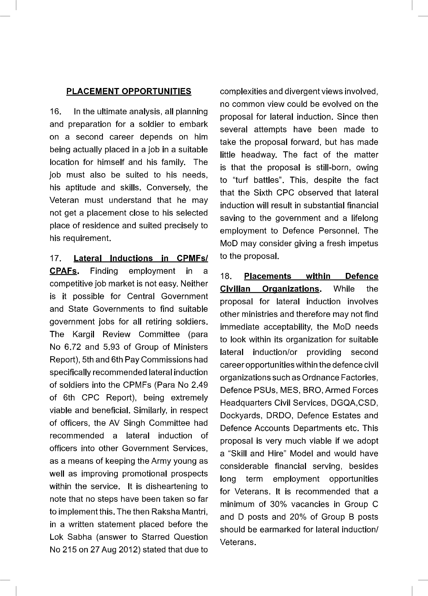
14 CENJOWS

- Implementing Recommendations of Parliamentary Committee on Defence
(16th Lok Sabha). The Standing Committee on Defence in its 33 rd Report (10.8. 2017) made practical and far reaching recommendations on the subject of “Resettlement of Ex- servicemen”. Some of the major recommendations are:-

- Enhancement in percentage of reservations in Group C and D

posts, PSUs and nationalised

Banks.

  - Relaxations in upper age limits for employment.

  - Placement of ESM in Ecological Task Force (TA) Battalions ,NDRF Battalions and Task Force for Ganga protection (Namaami Gange Project).

- The MoD should pursue these proposals with vigour.

- Placement in Private Sector. With the economy, especially in the private sector on a sustained momentum, there’s great scope for Veterans to be part of this success story. A concerted drive should be made in this direction. Defence manufacturing in the private sector has been given a substantial boost with the “Make in India” programme taking off in a big way. The MoD should consider negotiating with companies dealing with defence related manufacturing/service activities to provide job opportunities to Veterans through a “Skill

and Hire” or “Hire and Skill” programmes similar to the US model, described at para 8, above. Companies that hire 25% or more of their employees from Veterans may be given the status of “Indian Military Friendly Company”.

- ESM Organizations. There are a large number of ESM Organizations in the country; with varying aims and objectives, but mostly dealing with pensions, medical facilities and other related benefits that are entitled to Veterans, Widows and dependents from Central and State Governments. The grant of the long standing demand for One Rank One Pension (OROP) is a singular achievement of these organizations. Even through a few issues still remain, the Government has granted the OROP in a substantial manner. However, it is facile to think that receipt of pension alone is the panacea to all problems of a soldier retiring at the prime of his youth. In fact, his family commitments, especially with regard to growing children and their education, and other aspirations of his family increase manifold, while his income comes down drastically. Finding a suitable employment that augments his income to meet his family commitments is the biggest challenge he faces. The ESM Organizations, should, therefore, consider shifting their primary focus towards re-skilling and finding suitable employment for Veterans, widows and Dependents as their long term objective. They should harness the considerable good will that the

Armed Forces has with the general public and find ways and means to enhance self-employment/job opportunities for Veterans and families in the private sector. They could act as the conduit and a force multiplier, in driving this initiative.

- Veterans in the Corporate World.

A significant number of officers and men have pursued second career opportunities and have been hugely successful in the corporate world. The expertise and influence of these “combat to corporate” role models could be utilized in a substantive way. A quasi formal grouping of these Veterans could be considered to act as a “pull factor” and facilitators in reskilling and finding employment avenues for Veterans.

- Enabling Legislation. Reservation in posts given to Veterans in the Government Services, is more in the nature of “Executive Decisions”. Many of the posts remain unfilled since there is no legislative backing compelling the organisations to fill these vacancies. The Government should consider enacting a comprehensive and overarching legislation that addresses the issues of Veterans, especially with regard to assistance in education and skilling, providing for second career opportunities, lateral absorptions and aspects related to the welfare of welfare of widows and dependents. This would have a salutary effect on the lives of serving as well as retired soldiers and their families. The Act could be modelled on similar legislations enacted in the US and the UK.
CENJOWS 15

ACTION PLAN

25.. A close cooperation and partnership between the Defence and Corporate Sectors is a sine qua non, if we are to provide meaningful skilling programmes to the large number of military personnel, who join the Veteran ranks every year. A concerted approach involving the Government, the Industry and NGOs/private organizations is recommended in providing avenues of employment through lateral inductions, placements within the Government and private sector through “Skill and Hire” or “Hire and Skill” programmes; as also providing them requisite skills for self employment and entrepreneurship. An immediate action plan at the level of MoD and Service HQs on the following lines is recommended:-

- Evolve a detailed policy to support the second career settlement of Veterans.

- Initiate dialogue with the industry (through CII and FICCI) and identify companies that wish to participate in the “Defence-Corporate Partnership for Skill Development” initiative. These interactions should be initiated both at the Government as well as regional level.

- Establish one model Skill

Development Hub/Multi-Skill Training Centre in each regional command, within a time frame of one year, initially utilizing/pooling




