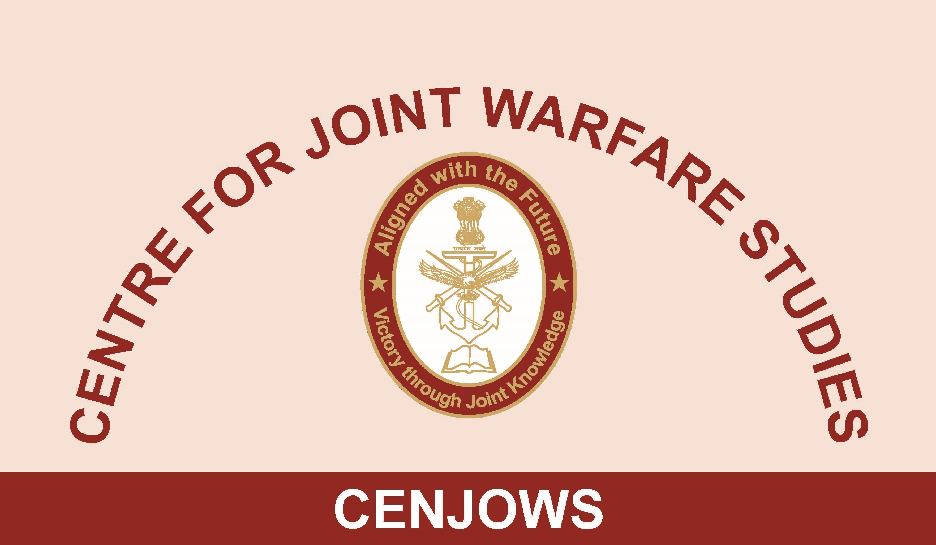
REPORT ON THE BOOK DISCUSSION
“STRATEGY TRAP: INDIA AND PAKISTAN UNDER THE NUCLEAR SHADOW”
AT PURPLE BAY ON 09 MAY 2019
BY
CAPT (IN) KK AGNIHOTRI, SENIOR FELLOW CENJOWS

Introduction
1. A Discussion about the newly published Book titled “Strategy Trap: India and Pakistan under the Nuclear Shadow” authored by Lt Gen Prakash Menon, PVSM, AVSM, VSM (Retd) was conducted at Purple Bay conference hall on 09 May 2019. The Author himself was present to elaborate upon the contents of his book. Lt Gen SL Narasimhan, PVSM, AVSM, VSM (Retd), Director General, Centre for Contemporary China Studies, and Prof. Rajesh Rajagopalan, Centre for International Politics, Organisation and Disarmament (CIPOD) of JNU were the two eminent subject matter experts who were invited as discussants.

2. Lt Gen Vinod Bhatia, PVSM, AVSM, SM (Retd), Director, CENJOWS, welcomed the distinguished Author, two eminent discussants and other audience. The Director, in his opening remarks, set the tone for further discussions by posing certain questions with regard to the ‘theory of deterrence’ and ‘its perspective in light of the Kargil conflict’. He sought an examination of the ‘theory of limited war’ in the context of tenuous India-Pakistan relations; and the impact of nuclear deterrence in shaping the behaviour of State and non-State actors. He requested the Author to cover some or all of these issues and invited him to discuss his book.

Discussion of the Book by Lt Gen Prakash Menon, PVSM, AVSM, VSM (Retd.), Author

3. The Author gave a historical perspective, background and context which enabled the book to be published. The idea germinated during his DSSC tenure in 1998 after India successfully conducted the Pokharan nuclear tests. So he went about writing his Ph.D thesis, which was largely premised on the theory that although conventional space under the nuclear overhang exists, it is insufficient to deter Pakistan and enable achievement of India’s political objective vis-à-vis Pakistan. He further argues that such conventional space is limited in terms of geographical confinement, skirmishes and limited war, at the most. He argued that this thesis was actually under test during Op Parakram, 2008 Mumbai Attack, and included terror events till the one in Uri in 2016.

4. He explains in the book that during Kargil conflict – not a limited war as per him – nuclear weapons on both sides were at infancy stage; and the related nuclear policies were non-existent. As the nuclear maturity has come to both sides after two decades now, the so called nuclear overhang is quite relaxed in the region. He feels that no matter what the rhetoric, including Pakistan trying to tell the World that this region is a ‘nuclear flashpoint’; the political leaders on both sides have shown a lot of maturity in decision making at critical junctures. The Author argued that two paradigms run concurrently in India’s options vis-à-vis Pakistan i.e. conventional forces are meant to win a conflict, while nuclear arsenal is for avoiding full scale war.

5. He however lamented the fact that limited war – with calibration of Force decided by the Indian political leaders – has just not been able to change Pakistan’s behaviour till date. What has possibly tied down the mindset of Indian political leadership in the past; is the fear of uncontrolled escalation borne out of factors like friction, chance and deep-rooted animosity between two sides. They fear that the consequently generated military momentum would be beyond their capacity to arrest. He also opined that ‘limited war’ remains an untested notion as far as India is concerned. Though the situation remains under control as long as it is in conventional domain, overt nuclear threat from either side will force a change in mindsets. This possibly explains as to why the Indian leadership continued to bear excessive number of terror attacks over the past decade and half, without demonstrated retaliation.

6. The Author finally argues that though the use of conventional force changes the status-quo only temporarily, the political leaders on both sides tend to encash such tactical successes in a big way. This is a dangerous trend in a region where both States are armed with nuclear weapons; and Pakistan is not limited by ‘no first use’ doctrine. In order to moderate such a dangerous trend, the Author recommends immediate appointment of the ‘Chief of Defence Staff’ as a single point military advisor to the political leadership, precisely because India is a responsible nuclear power. He argues that the current arrangement of Chairman, Chiefs of Staff Committee – who also has the primary responsibility to run his own service – is just not suitable for handling the gravity of the situation when it arises.

Comments by Prof. Rajesh Rajagopalan, Discussant

7. The Prof. congratulated the Author for a very comprehensive treatment of the subject which is so relevant in the contemporary India-Pakistan context. He began by pointing out that terminology usage in nuclear doctrinal framework is very important, so as to leave no room for ambiguity. He averred that there were a variety of pressures on India’s nuclear policy. The external pressure relates to how the Nation would be perceived by other countries. The internal pressures on the other hand, relate to the ‘diversionary theory of War’ under which the political leadership seeks to look at war to divert the attention of the populace from domestic governance issues of critical nature.

8. He averred that when India formulated its Nuclear Doctrine in 2003, it was extensively criticised, with ‘for’ and ‘against’ constituencies deeply divided. He opined that the ‘no first use’ policy does not seem to have been fully grasped by the Indian political leaders and nuclear strategists. He also disagreed with the Author by suggesting that massive retaliatory suggestion of India in response to Pakistan’s use of ‘tactical nuclear weapons’ was not very credible. Instead, he advocated a more flexible response entailing calibrated retaliation depending on the adversary’s scale of nuclear attack. He also suggested that there should not be automatic progression in the escalation matrix from conventional to nuclear warfare, as the Author has suggested in his book. Instead, escalation in his view, should be a deliberate decision by the political leadership.

Comments by Lt Gen SL Narasimhan, PVSM, AVSM, VSM (Retd.), Discussant

9. Lt Gen Narasimhan began by pointing out that a thread that continuously ran through the whole book was ‘nuclear deterrence’. He averred that acquisition of nuclear weapons is treated by weaker nations as an insurance against the stronger ones; and thus is main driver for nuclear proliferation. Pakistan has used this analogy quite aptly by leveraging its nuclear arsenal to shape Indian minds in peacetime. It, of course, realises that the deterrence remains only till the first weapon is fired. Complementarily, deterrence only works till the other party believes in it.

10. The second thread through the book relates to ‘limited war’. However, he was certain that ‘limited war’ undertaken in a linear fashion would not be sufficient to alter Pakistan’s behaviour towards India. Therefore, other State machinery, resources and instruments – like economic strength and foreign policy options – must be used in tandem for better outcomes. He argued that since the terms of ‘massive retaliation’ in the Indian nuclear doctrine were not clearly defined, it did give India enough flexibility to decide on the quantum of retaliation, as suggested by Prof. Rajagopalan. At the same time, it clearly affirmed Indian stand of simultaneous ‘signalling’ and ‘resolve’. He also, very clearly stated his conviction that while minor irritants vis-à-vis Pakistan could be taken up with other countries for resolution/ redress; India will have to go it alone when it chooses the hard option of war fighting.

Conclusion

11. The Book discussion was followed by animated question and answer session. One particular questioner wondered as to why the book sought to propagate a defeatist ‘can’t do much’ attitude with respect to Pakistani nuclear threat and its proactive leverage of this capability. Another question related to Indian armed forces modernising its conventional war fighting capabilities when the book suggested that there are negligible possibilities of a conventional war.

12. The Author responded that this was precisely the ‘strategic trap’ that the book’s title so aptly encapsulated. He said there were no operational answers which could get the two countries out of this situation. Thus, no solution except political sagacity seems to be immediately viable. The Author felt that the Indian Armed Forces were, of course, modernising in the wrong manner; but it is for the political leadership to provide the correct national conceptual direction, before a suitable course correction can be undertaken.

13. The book discussion concluded by final remarks from Lt Gen Vinod Bhatia (Retd.), Director, CENJOWS, who stated that the book’s publication could not have been more well timed, particularly when the nuclear debate was at high point after Pulwama terror attack followed by Balakot bombing and subsequent air action. He thanked the Author, two distinguished discussants and the informed audience for active and whole-hearted participation in the event.

