
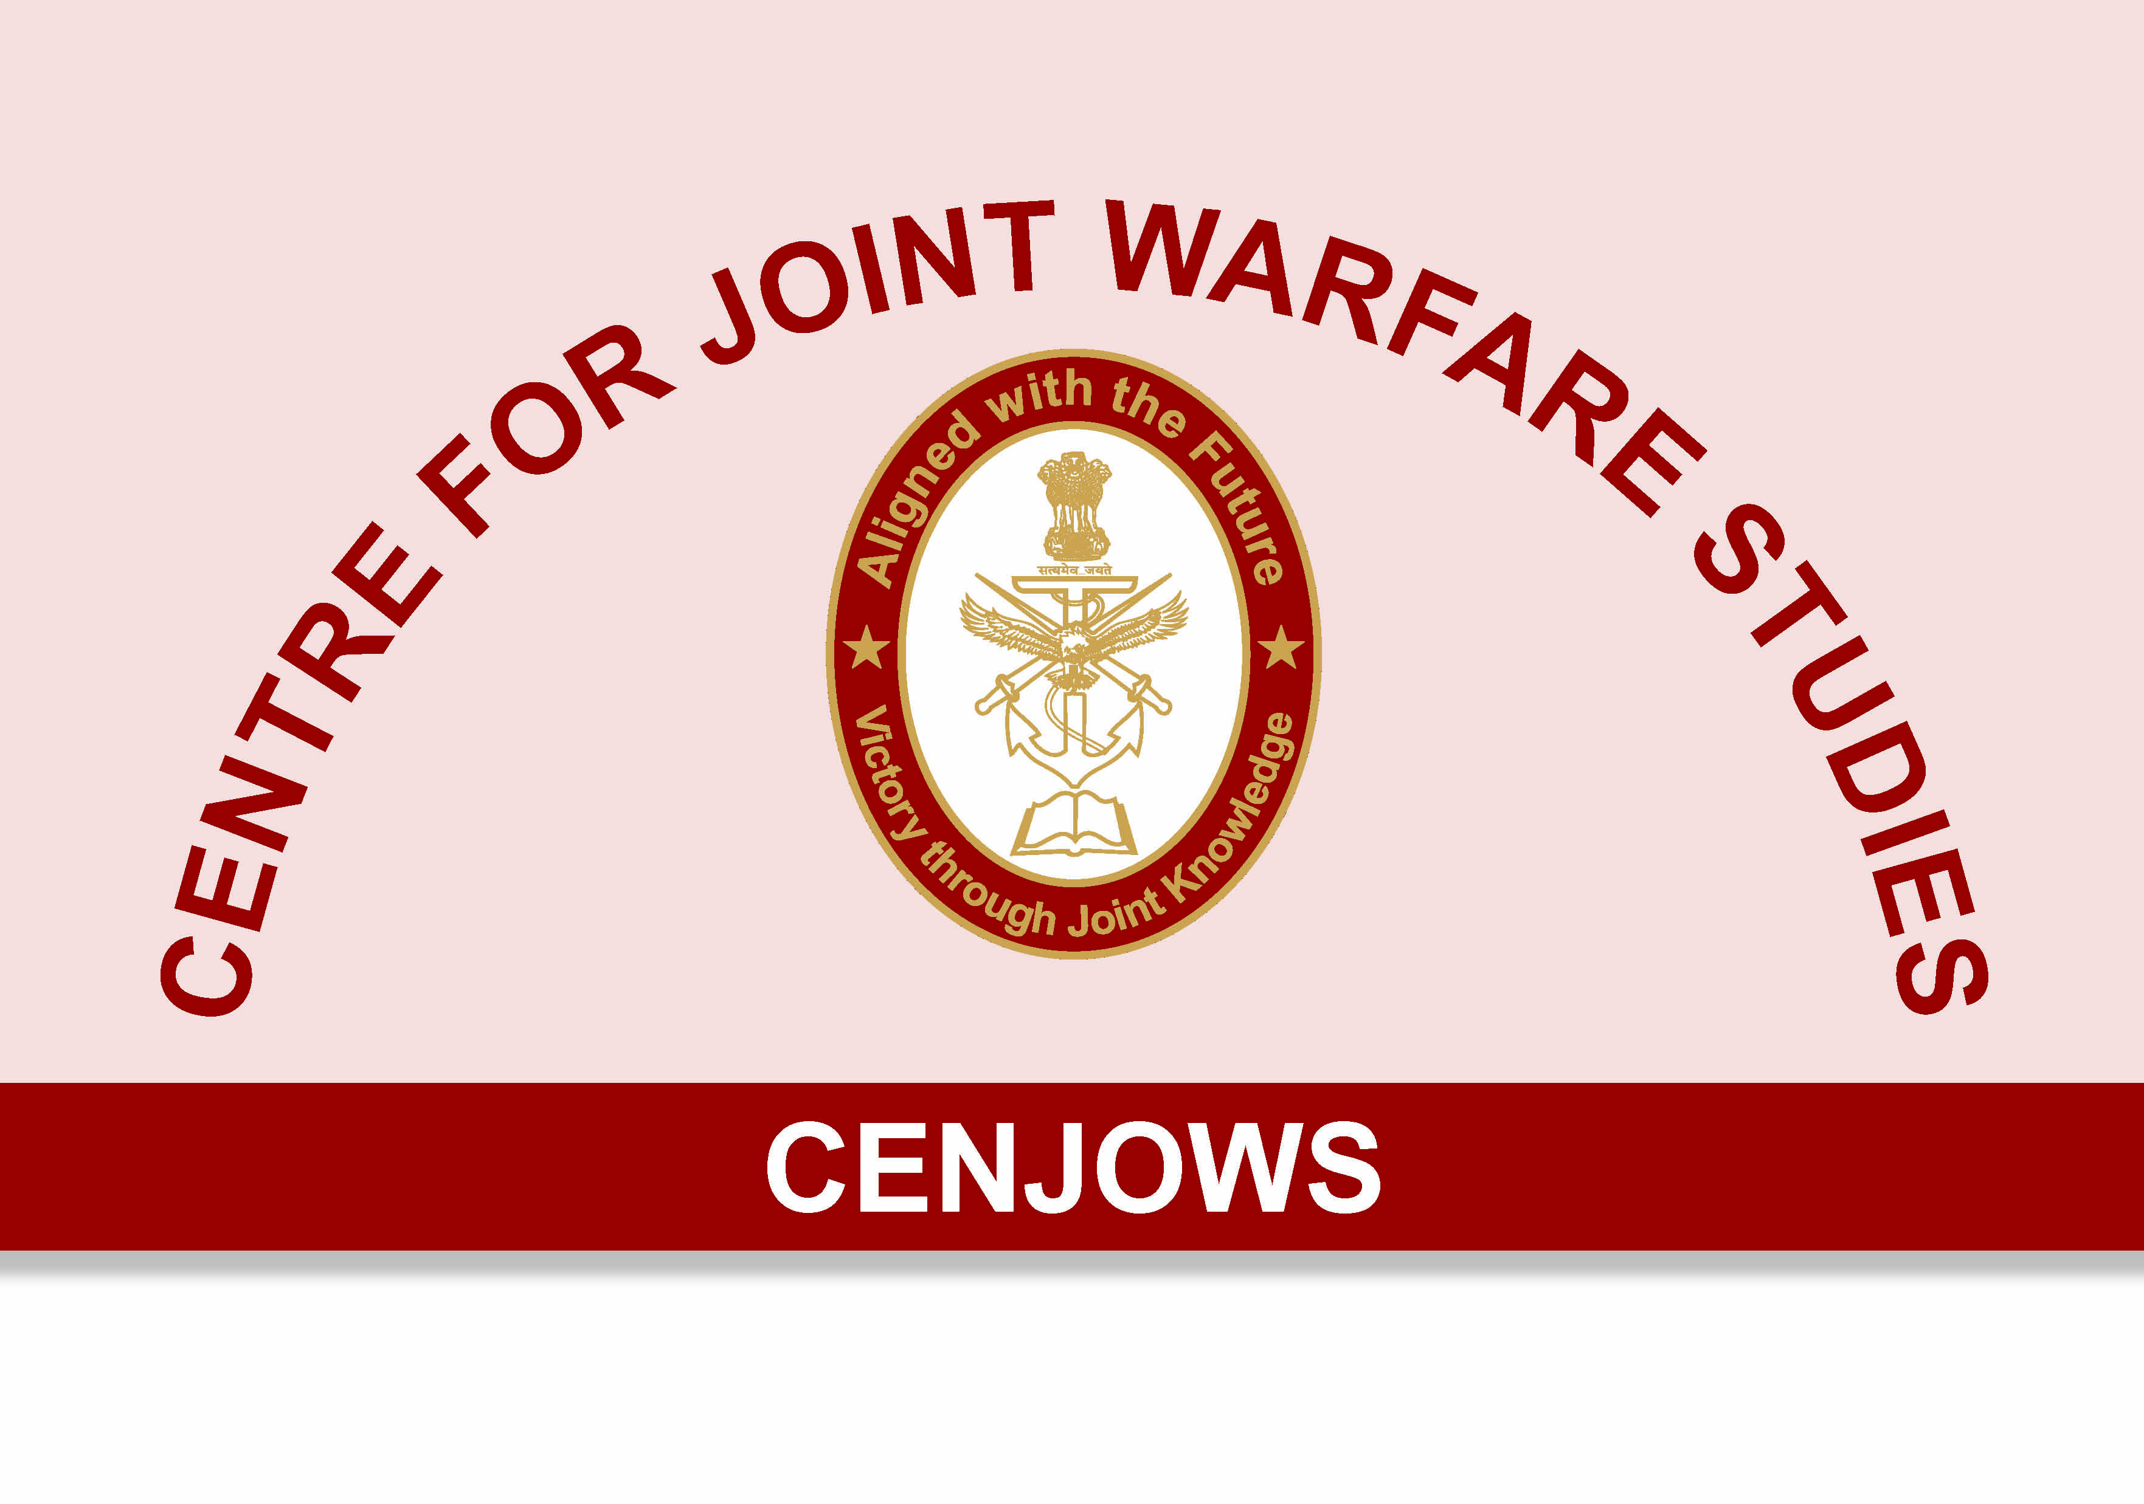

MISSION ENGINEERING THE FIC

Lt Gen (Dr) N B Singh,
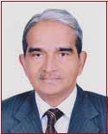
PVSM, AVSM,VSM (Retd)

is a former DGEME and DGIS. He frequently writes on Systems Engineering and Knowledge Leadership issues. Currently, he is a Member at the Armed Forces Tribunal, Jabalpur. The views expressed are his personal.

“In the operations at Chushul the French tanks were not required to move long distances
since they supported Infantry by fire. However, the starting of cold engines with the ‘ether pilot start kit’ was not satisfactory and neither was the kit for hot air blast available to the LAD: as such the engines were periodically started and stopped during the night with the plugs cleaned and refitted. By this

process, all the six tanks started for the operations. One engine failed as a result of abnormal wear and tear due to long static running and periodic starting and stopping; another failed because header tank of the radiator exploded. It was experienced that all engines needed superchargers without which even new engines would not give optimum performance as there was a loss of 45 percent horsepower due

- 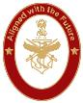 CENJOWS


to height alone. If these tanks had been available at Rezang La in a fighting fit state, the outcome of the battle would have been different.”

The above facts of history are relevant even today as our battle field environment has become even more challenging in the last 55 years. The 21st Century has been called the ‘The Systems Century.’ Complex Systems like the Future Infantry Combat Vehicle cannot be designed, developed in isolation and then fielded for optimum operational deployment & usage. It is important to take a full systems view of this flagship project before embarking on this programme. This is essential because decisions have to be made today in the face of increasing complexity, uncertainty & rapid change; for a weapon system that will be put to full operational use at least after a decade. To commence with, the entire process of design, development, acquisition & through life support needs to be taken up as a capability acquisition endeavor comprising operational, technological & resuscitation capabilities.

GiventheimportanceofSystem Maturity (SM) & System Readiness (SR) within the systems engineering

process, it is important that these two distinct entities are fully addressed during the development phase. Else, there are chances of the Army being saddled with a system designed for Northern Europe, which may possess a significant number of fancy technological features but when fielded in our operational environment, will fail to deliver. Without going into the complexities of the two, suffice would be to understand that a system has to be ‘mature’ before it can be ‘ready’ for use. One starts with System Requirements and ends with System Verification while the other; from User Requirements to System Validation. Hence, the essence is to build the right system for a given context.

The obvious question that now arises is ‘right’ for what? Herein comes the question of

System Effectiveness (Mission Capability), i.e., the ability of the System that has been developed to achieve mission objectives or desired operational out comes.

The diagram below (Abideen Tetlay

- Philip John, Cranfield University) gives out the general approach to achieving System Effectiveness.

 | System Effectiveness
User |  |  | System
Requirements |  |  | Validation
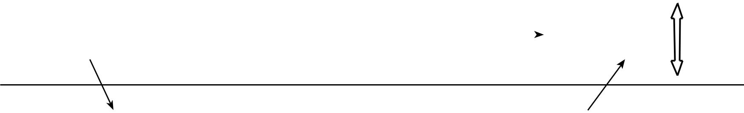

System | Verification |  | System
Requirements |  |  | Verification



 |  |  | Integration, Verifi-
Architectural | Verification |  | Integration, Verifi-
Architectural |  |  | cation & Testing in-
System Design |  |  | cluding Prototyping


Sub-system
Sub-system | Verification |  | Sub-system
and Component |  |  | Sub-system
and Component |  |  | Integration,
Design |  |  | Integration,
Design |  |  | Verification & Testing
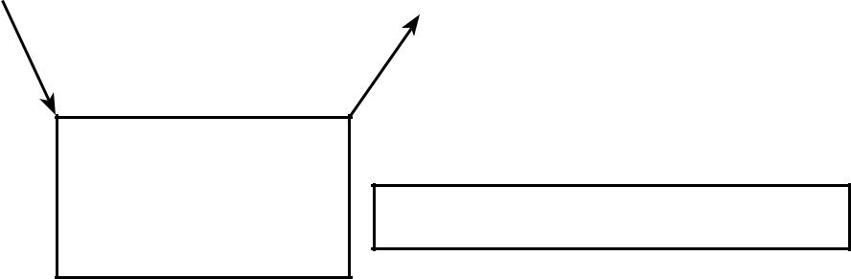

Build

System development lifecycle

System

Readiness

System

Maturity

CENJOWS


- 3 CENJOWS

Thus, it is crucial that any system being developed in this century for the Indian Army must have operational capabilities to match the operational tempos envisaged. At the sub-system level, it could be capability measures like accuracy, range, lethality, payload, number of engagements, destructiveness etc. What about at full system level? What should be the operational capability the FICV should possess when it is cleared for acquisition and deployment? This calls for a comprehensive mission engineering exercise to be undertaken where lessons from previous wars, exercises and war games, equipment capability of adversary, experiential knowledge gained consequent to fielding and operational sustainment of current systems; could help spell out the mission capabilities desired from the new system taking the emerging operational challenges into account.

There is no point in wasting the country’s scarce resources on a programme that has created so much ballyhoo, if at the end of it, the product has capabilities similar to an upgraded ICV BMP-2 or is a clone of a foreign ICV. The

COAS has aptly stated that the Army`s True North is indeed to the

North and hence future equipment capability development has to focus on this requirement.

- Taking into account numerous challenges the Army has faced since independence in deploying armored vehicles in mountains and high altitudes be it, Zojilla (1947), Chushul (1962), North Sikkim (1980s), Leh and beyond in recent years and fielding of other weapons in high altitudes and glaciated

regions, it would be advisable to develop the FICV around the operational tempos envisaged in mountains and high altitude areas. A proper mission engineering exercise carried out by the mechanized forces (DGMF) along with the sustainment engineers (DGEME) could spell out the capability metrics for such scenarios. Once this is achieved, fielding of the FICV in plains and deserts would become much easier, as it would entail tweaking of a few technical performance measures (TPM) only. But the reverse may not be true as the experience of past 70 years has shown. A system not designed for duty in mountains and high altitudes fails to perform optimally when inducted in these regions. Foreign OEMs have discovered much to their chagrin that

even radars deployed in high altitude areas in India, malfunction due to the rarefied atmospheric conditions prevalent there. The changing nature of threat on our northern border also demands that such an approach be adopted in the development of most futuristic systems for our Army. It has been reported that our Northern neighbour focuses on extracting 10-15% additional equipment capability in every successive exercise. The one size fits all approach generally adopted in our context is a major fault line in equipment readiness of our formations. Pointless deploying armored vehicles in such areas, if these are not likely to deliver the specified missions when required, as happened at Chushul. Kargil did throw up some tell tale signs but it was quickly forgotten. One can only hope that the framing of GSQR for the FICV has been done wisely and pragmatically after requisite gap analysis and has not been merely a cut and paste exercise. This entire programme is going to cost the Nation a huge sum and at its conclusion, we should not end up with a Arjun like system with very few takers. Arjun as a system is a case of ‘System Maturity in Progress’ and ‘System Readiness
CENJOWS 5



not achieved’, despite long years of development and validation. Much of this can be ascribed to the frequent ``Requirements Drift from the User’’ and absence of a systems view at the top. Arjun`s development is a classic case of “attribute centric” development instead of “capability based”. Capability wise, perhaps it is at par or even better than most AFVs in our inventory. We should not end up achieving a similar state in the FICV programme. For armored vehicles to be able to deploy, fight and survive in mountains certain technological features have to be embedded in the sub-systems ab-initio or else it may malfunction under the effects of age, usage and deployment (environmental effects) and severely degrade capability readiness of formations. FICV could well be the first bespoke weapon system for the Mountain Strike Corps, which certainly will need agile and aware units to meet its operational commitments. A smaller, lighter & faster combat vehicle could be deployed faster than tanks to defend a remote outpost on the northern border, be employed during stand offs and against developing mechanized threat in the north. It would also find use in defence of island territories
- CENJOWS

besides finding employment in Rapid Reaction brigades which one hopes may become a part of the Mountain Strike Corps.

Given below is a technology tree for the FICV. One can see that hundreds of sub-systems and thousands of components will have to be designed/ developed/ procured to carry out the prototyping. Subsystem integration, verification and testing would become crucial to achieving system maturity of the final build. Design for abilities, ie. system reliability, availability, maintainability and durability (RAM-D), would be critical, all sub system manufacturers will have to give out details of engineering life to the System Integrator. It would be prudent to consider system readiness under heads of

Firepower, Survivability, Mobility, Fightability and Simulation systems and then stipulate mission capability (equipment capability) rates for the full system. (Fig Page No. 7)

Metrics for Initial System Readiness (ISR) and Final System Readiness (FSR) could be firmed up and included in the trial procedure. The system should be cleared for induction on achieving ISR and the target should be to achieve FSR

within 5 yrs of initial deployment along with full resuscitation infrastructure. Needless to mention, some growth potential or scope for added technological improvements may be included in the GSQR to defeat obsolescence. The system could be outfitted to support Infantry operations in mountains and include several variants like ICV, wheeled APC, light tank, bunker burster ,tank destroyer, mobile gun system, weapon carrier and repair and recovery vehicle to provide the economy of scales to system and sub-system houses & the Systems Integrator.

In conclusion, I would end on the note that the FICV programme should not become a Make in India initiative, where a foreign system is tweaked and built under ToT by public/ private sector . It should be a truly capability centric initiative aimed at enhancing the Army`s war fighting capabilities in mountains, plains and deserts , besides genuine creation of an industrial base with exclusive capabilities of design, development, testing, evaluation, manufacturing and sustainment of complex land systems to suit Indian conditions, thus contributing to Technology Security of the Nation. It should
CENJOWS 7
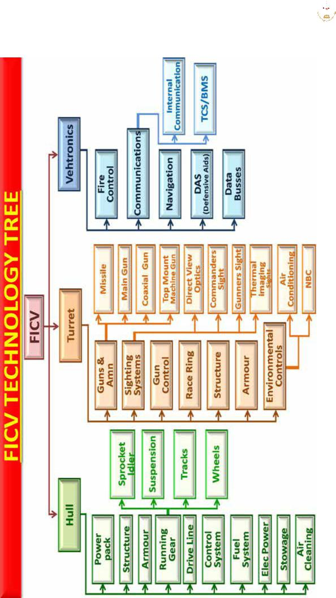

- CENJOWS

come out as a Make for India, by India and in India programme driving productivity and innovation in our Defence Industrial complex.

Planning for a capability requires

a whole different way of thinking from the conventional equipment procurement, the establishment is used to.

Centre for Joint Warfare Studies

Kashmir House, Rajaji Marg, New Delhi-110 001 Tel. Nos : 011-23792446, 23006535, 3306538/9, Fax : 011-23792444 Website : http://cenjows.gov.in, e-mail : cenjows@yahoo.com

