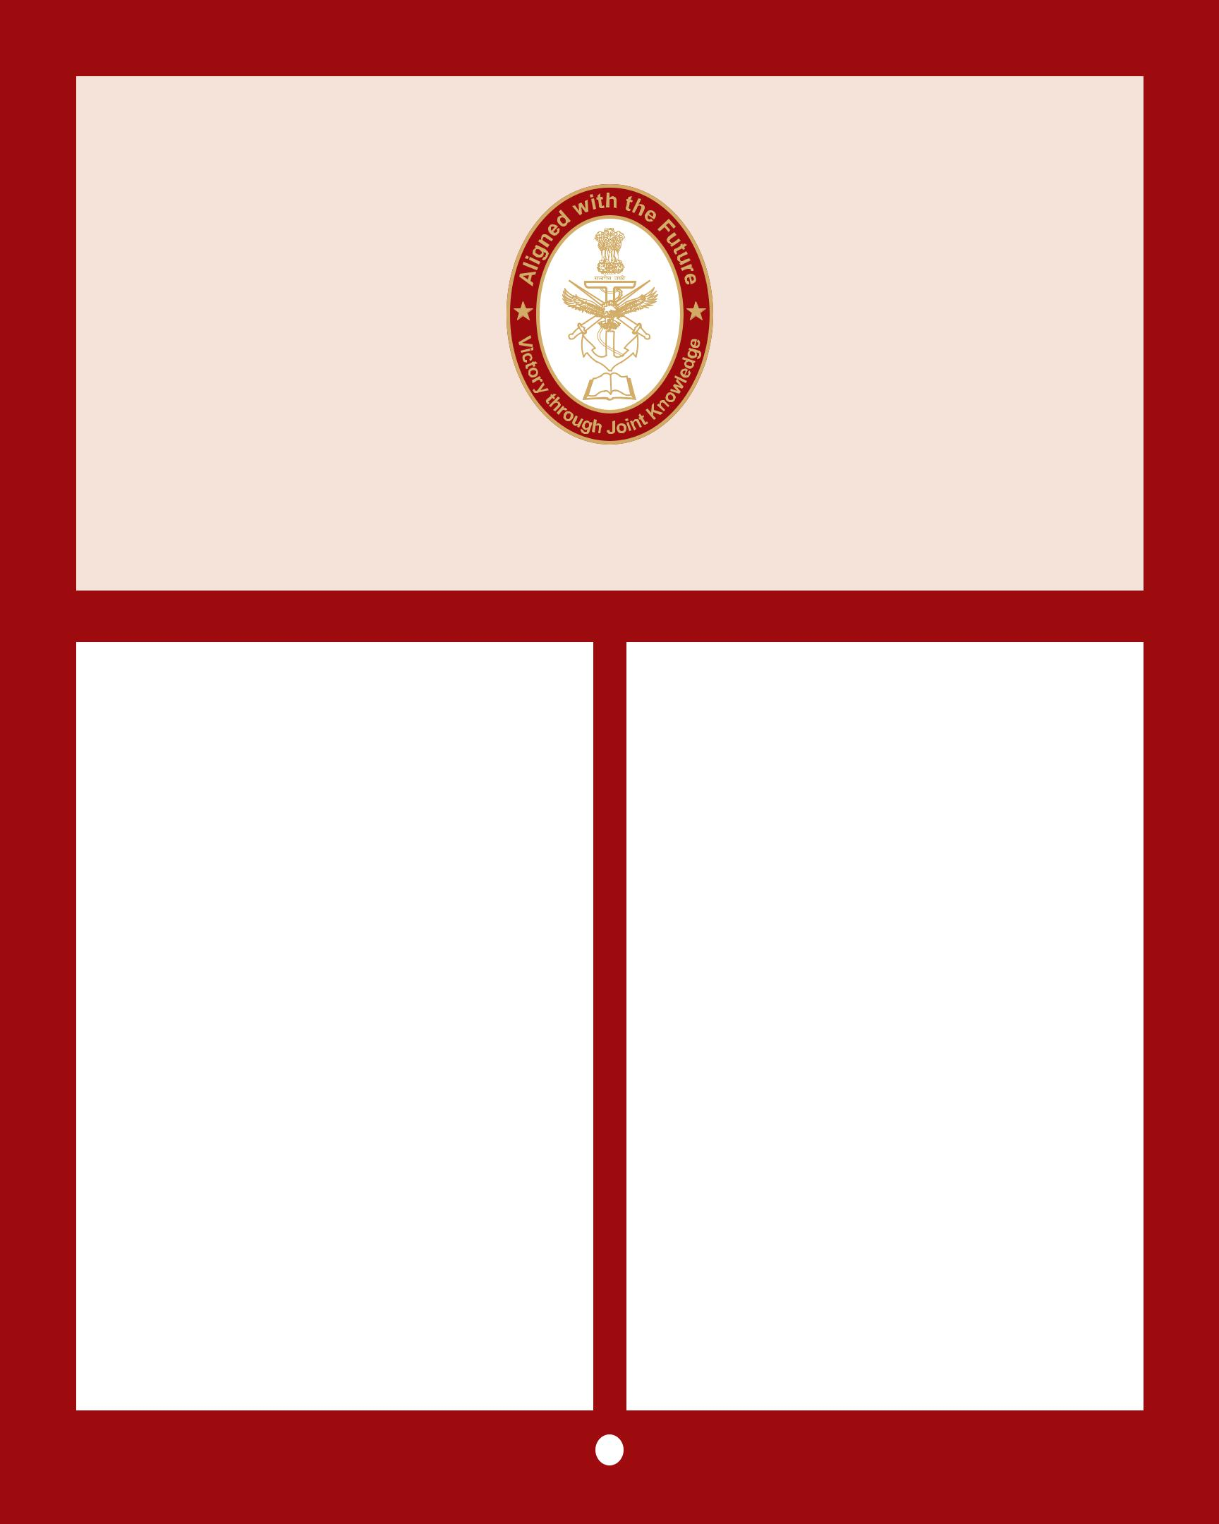

FREEDOM OF NAVIGATION IN

THE SOUTH CHINA SEA

SYNODOS PAPER | VOL - X NO 3 / OCT 2016

Introduction

Aclearandunambiguousreadingofinternational

norms regarding freedom of navigation is

compelling as more nations acquire the naval

capability to act in the maritime domain. While

all nations acknowledge the importance of free

navigation of commercial vessels in the region

there is disagreement on the important issue of

freedom of navigation for military vessels.

Maritime powers believe all nations have wide

latitude under international law to conduct

military activities at sea. China, a revisionist and

emerging maritime power argues that military

activities in the South China Sea infringe

on Chinese sovereignty. The disagreement

has resulted in several confrontations at sea

between the two nations and has implications

for peace and security in the SCS.

The South China Sea is a major shipping route and home to fishing grounds that supply the livelihoods of people across the region. Each year, more than 70.000 vessels and $5 trillion in maritime trade passes through the South China Sea’s waters. It is a strategic corridor for maritime trade, contains lucrative resources,

and is the subject of competing claims. Although largely uninhabited, the Paracels and the Spratlys are believed to have significant reserves of natural resources around them. There has been little detailed exploration of the area, so estimates are largely extrapolated from the mineral wealth of neighbouring areas. Rival countries have wrangled over territory in the South China Sea for centuries, but tension has steadily increased in recent years.

Freedom of the Seas

Freedom of the seas is a principle in international law that gives the right to all states to use non-territorial waters for fishing, laying of submarine cable or pipeline, navigation, over-flight, scientific research, etc. It provides ships of all nations to sail the high seas in peacetime, accords immunity to neutral ships from attack during conflict and gives exclusive jurisdiction to a state over its ships sailing the high seas in peacetime.

The doctrine stresses freedom to navigate the oceans. The concept arose in Europe in the fifteenth and sixteenth centuries. Queen

1


Elizabeth I of England proclaimed that, “The use of the sea and air is common to all; neither can any title to the ocean belong to any people or private man.” The most notable assertion of the principle of freedom of the seas was the book Mare Liberum (1609) by Dutch jurist Hugo Grotius who defined the seas as being, like the air, limitless and therefore common to all people.

Historically, Freedom of the Seas has been one of the chief means by which the maritime powers have influenced international affairs. In the meddle of the twentieth Century nations started to expand and claim many resources and territories off their coasts. This led to four international treaties in the late 1950s to the 70s, but the issues were not entirely resolved until 1982 when the United Nations Convention on the Law of the Sea was introduced. The UNCLOS, a ‘Constitution for the Oceans’ is an agreement of rights and responsibilities of nations and their use of the world’s ocean with regards to trade, environment, and the management of marine and open seas resources.

The agreement established the twelve-mile limit for territorial waters and a two-hundred-mile exclusive economic zone. The treaty refers to the world’s oceans as the common heritage of mankind and is a shift away from Grotius’s notion that the seas were free owing to their boundlessness. Rather the seas are now understood to be a zone of interdependence in which all nations including landlocked ones have a stake. As of 2013, 165 countries and the European Union have joined the Convention.

Freedom of Navigation and the South China Sea
Nowhere is the issue of freedom of navigation more contentious than in the South China Sea (SCS). This is because all rights and entitlements enshrined in the UNCLOS treaty derive from sovereignty of land or island territories. This is the root of the South China Sea dispute.
China claims almost all of the sea to be historically part of its territory and in recent years has been aggressively creating artificial islands to bolster its position, including the building of airstrips. Its actions have been an increasing source of tension in the region and beyond. In April this year, the G-7 issued a statement supporting arbitration, voicing strong opposition to any intimidating coercive or provocative unilateral actions that could alter the status quo and increase tensions.

There are fears that the area is becoming a flashpoint, with potentially serious consequences. The most serious trouble in recent decades has flared between Vietnam and China, and there have also been stand-offs between the Philippines and China. In 1974 the Chinese seized the Paracels from Vietnam, killing more than 70 Vietnamese troops. In 1988 when the two nations clashed in the Spratlys, Vietnam lost another 60 sailors.

In early 2012, China and the Philippines engaged in a lengthy maritime stand-off, accusing each other of intrusions in the Scarborough Shoal.

The South China Sea Dispute
The South China Sea has two clusters of islands. Alongside the fully fledged islands, there are dozens of rocky outcrops, atolls, sandbanks and reefs, such as the Scarborough Shoal. The ongoing disputes mainly concern the Spratly Islands, with ASEAN claimant countries asserting incompatible claims.

China, Vietnam, the Philippines, Taiwan, Malaysia and Brunei all have competing claims over territory in the South China Sea. China claims by far the largest portion of territory - an area defined by the “nine-dash line” which stretches hundreds of miles south and east from its most southerly province of Hainan.

Vietnam claims that it has actively ruled over both the Paracels and the Spratlys since the 17th Century - and has some supporting documents.

2

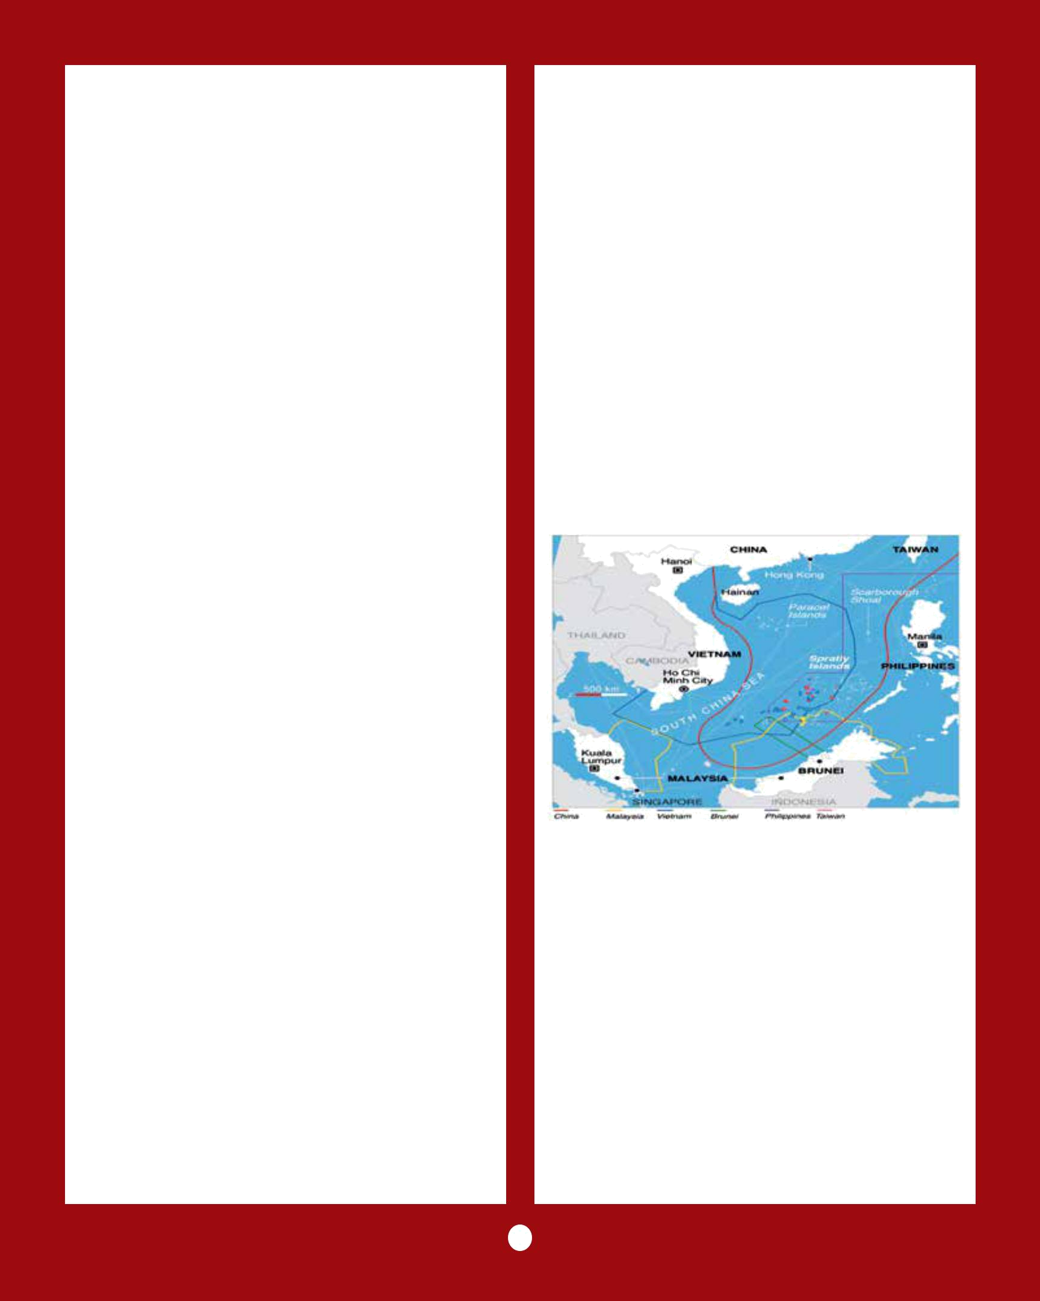
Both the Philippines and China lay claim to the Scarborough Shoal- a little more than 100 miles from the Philippines and 500 miles from China. Philippines, invokes its geographical proximity to the Spratly Islands as the main basis of its claim.

Malaysia and Brunei also lay claim to territory in the South China Sea that they say falls within their economic exclusion zones, as defined by UNCLOS. Brunei does not claim any of the disputed islands, while Malaysia claims a small number of islands in the Spratlys.

Among the Spratly Islands, 50 are occupied, 29 by Vietnam, five by Malaysia, eight by the Philippines, seven by China, and one by Taiwan. China holds that it has complete sovereignty over the Paracel Islands and that there is no dispute but they claimed in whole or in part by a number of countries.

Spratly Island is under Vietnamese control. It has an airport, a migrant population and a military presence. Vietnam’s headquarters for the Spratly Islands are also located here. The Philippines has done the same on Thitu Island. Malaysia has carried out large-scale reclamation on Swallow Reef, and has built an airport, a harbour, and even hotels to promote tourism by transforming it into an international hotspot for diving.

Ever since the ratification of the UNCLOS in 1982 and after ASEAN and China signed the Declaration on the Conduct of Parties in the South China Sea in 2002, every claimant country in the region has been changing the status quo. They either began new oil and gas drilling, or built new structures, or resumed land reclamation.

China’s ‘Nine-Dash Line’ in the South China Sea

The Chinese Nationalist Party (Kuomintang), issued a map that indicates that the dashes demarcate the ‘positions of the various islands
in the South China Sea.’ When this line was first drawn by the Kuomintang in 1947, China did not carry out surveys of all the islands to identify and demarcate the surrounding administrative zones. It instead drew a line between the islands and the neighbouring land to indicate that all islands within the line are Chinese territory. This line is generally positioned in the midpoint between the outermost periphery of the islands and the nearest landmass. No exact geographic positions are given, and maps issued in different periods have differences regarding the exact position of the nine-dash line.

There are generally four interpretations of what the line is, namely either as a demarcation of maritime borders, sovereignty over islands, historic rights, or historic waters.

- The line as maritime borders. The line is the extension of national borders on the sea, inside which lie internal waters. This would effectively mean the entire South China Sea belongs to China, which is unacceptable to the neighbouring countries as well as the international community. This view is endorsed by few Chinese scholars and is perhaps only held by a handful of powerful elements in the government.

- The line as demarcation for claiming sovereignty over islands. All islands within the line belong to China and the surrounding waters within 12 nautical miles of each island

3

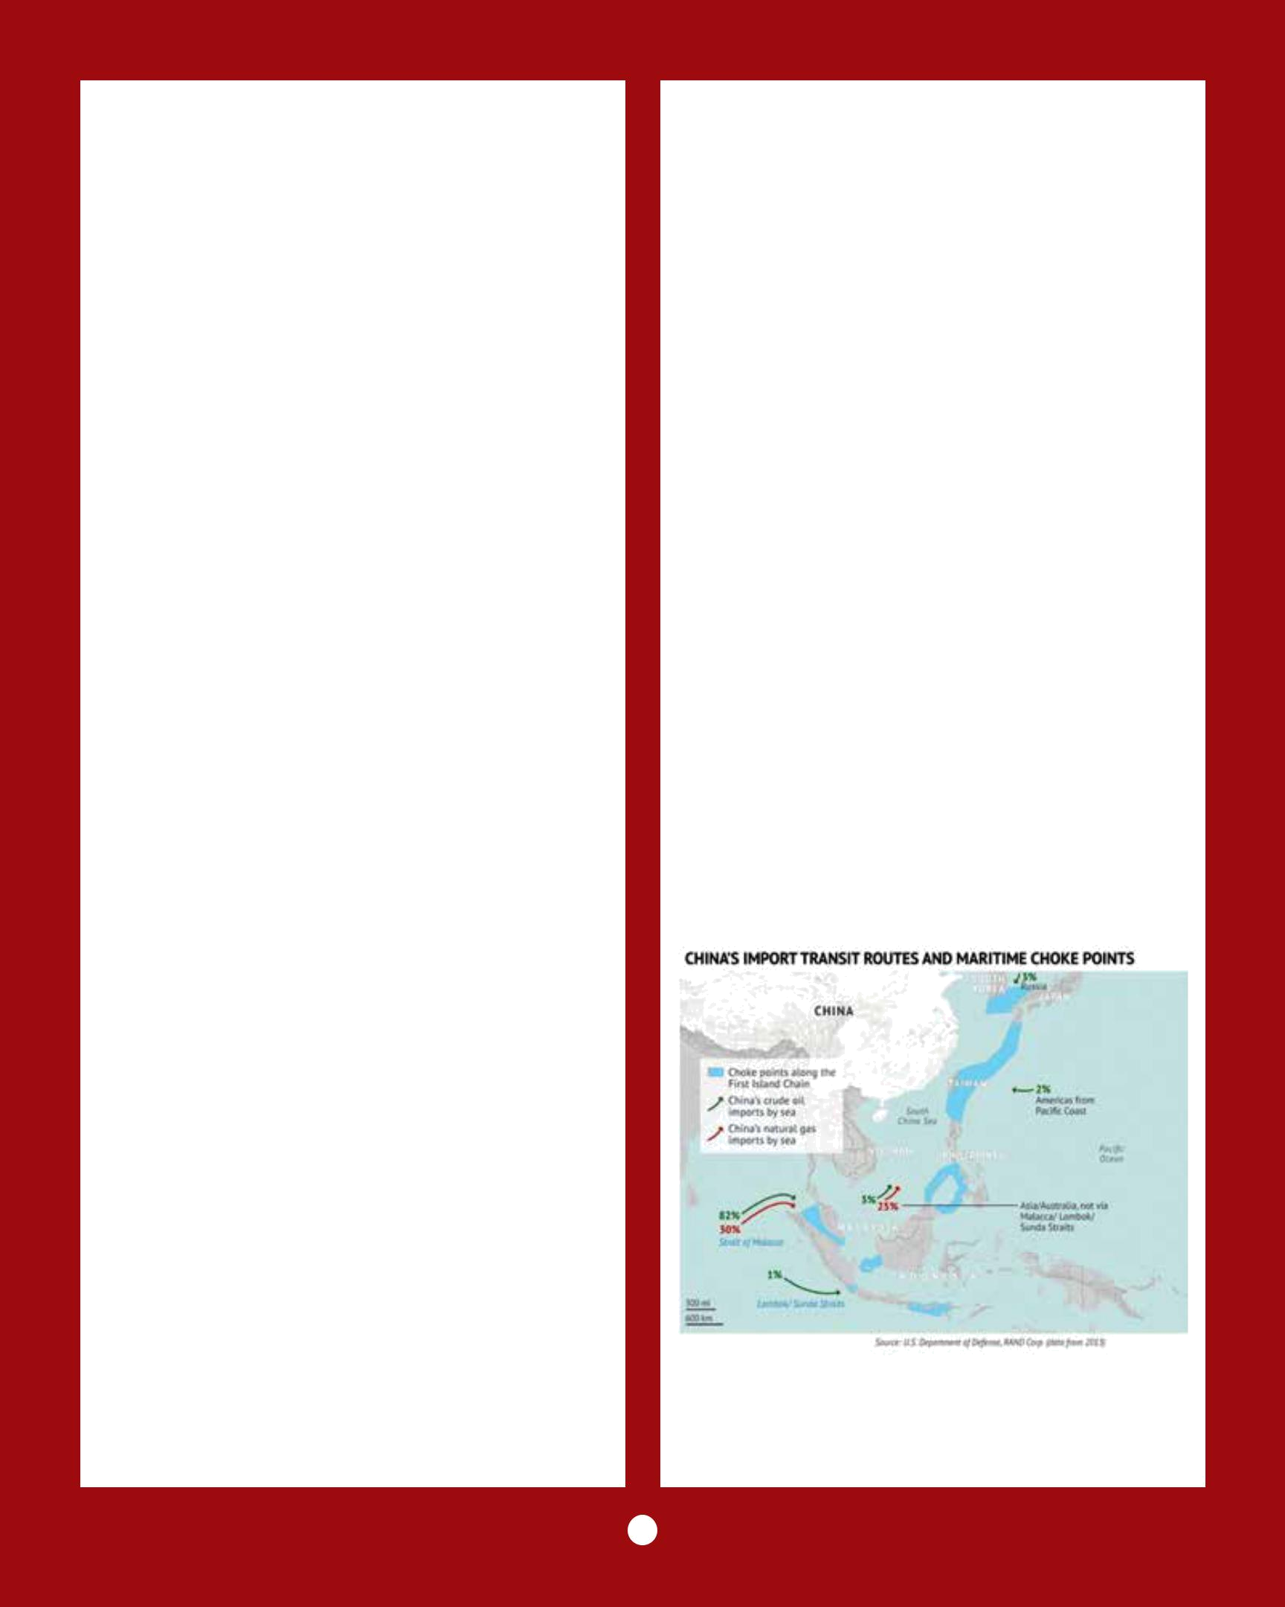
are China’s territorial waters, outside which lie China’s contiguous zone and exclusive economic zone. This appears to be in line with the Chinese Nationalist Party (Kuomintang) concept.

- The line as demarcation for historic rights. The islands within the line belong to China and the surrounding waters within 12 nautical miles of the islands are China’s territorial waters, and China is entitled to its “historic rights” over the sea outside its territorial waters. There is, however, no clear definition as to what these historic rights are. Historic rights on the high seas do not appear to be consistent with any international norms.

- The line demarcating historic waters. This view was proposed by Taiwan in its Policy Guidelines for the South China Sea issued in 1993. Historic waters are similar to internal waters, but with a lower legal status. Policy Guidelines were scrapped in 2003 by President Chen Shui-bian, but Taiwan did not issue any new statements regarding waters within the nine-dash line, so it may still view them as historic waters.

China sees the nine-dash line as means for demarcation of sovereignty over islands and surrounding waters. There is, however no consensus amongst Chinese analysts about the legal basis for the line and may be the reason for the ambiguity in Chinese statements about it.

China’s View

China prefers bilateral negotiations with other claimant states as its relative size and clout give it a great advantage. It may be willing to make small concessions and has been pursuing a two-track strategy, maintaining that issues of sovereignty over the islands as well as maritime demarcation be negotiated by the parties concerned. It desires that peace and stability of the South China Sea be maintained by both ASEAN and China and that extra regional powers should not be involved in
the negotiations of sovereignty, nor intervene in the disputes. Some countries have argued that China should negotiate with ASEAN (the Association of South East Asian Nations), a 10-member regional grouping that consists of Thailand, Indonesia, Malaysia, the Philippines, Singapore, Brunei, Laos, Vietnam, Myanmar and Cambodia. China is opposed to this and ASEAN is divided over how to move forward on the dispute.

The Philippines has sought international arbitration instead. In 2013, it announced it would take China to a UN tribunal under the auspices of the UN Convention on the Laws of the Sea, to challenge its claims. China consistently boycotted the proceedings, insisting that the panel has no authority to rule in the case. It has stated that it will not abide by the UN tribunal’s ruling.

The internationalization of the conflict has complicated the situation that already involves five or six parties. China is enraged by the US bringing in Japan and India and questions how these countries can negotiate with parties to the dispute.

A Strategic View of the SCS Dispute

The above is an illustration of China’s accesses to the seas and their potential of being choke points against China. As a rising power China

4

would desire to control those access points so that they do not become strategic choke points. That would suggest that China’s claim to the entirety of the SCS is more strategic than economic. Having a persistent military presence in the SCS on islands would allow China to quickly respond to any threat, or potential threat, to its access through the choke point. China’s prosperity lies more through unhindered trade than from exploitation of any natural resources in the SCS.

Understanding Freedom of Navigation Freedom of navigation (FON) is a principle of customary international law that protects ships flying the flag of any sovereign state from interference from other states. This right is now also codified as article 87(1)a of the 1982 United Nations Convention on the Law of the Sea (UNCLOS).

In its most basic understanding, freedom of navigation is a ship’s or aircraft’s right to transit the maritime domain and conduct operations during transit. Three factors help determine freedom of navigation rights.

(a) Sovereignty over land territory must
be established because maritime rights and duties generally originate from the coasts or islands. Sovereignty is, of course, a source of major dispute in the SCS.
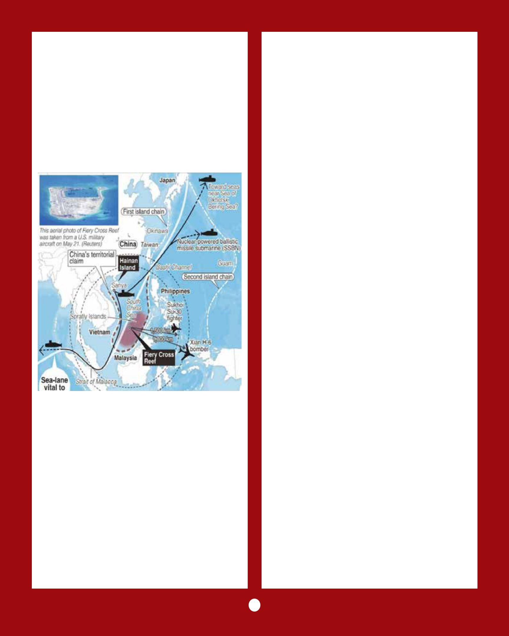

- Assuming that sovereignty over land territory is clearly established, various maritime zones are derived by measuring distances from land features. While these measurements are often straightforward and undisputed, frequently they are not. China, for example, measures its territorial sea from a series of “straight baselines” along its coast without regard to the UNCLOS rules thereby increasing its sovereignty over its near-coastal waters.

- Once maritime zones are established in relation to sovereign territory, the final

analysis relevant to determining freedom of navigation rights concerns the types of operations permitted within specific maritime zones. The controlling international agreement governing permissible conduct within international maritime zones, as well as the zones themselves, is UNCLOS.

The Exclusive Economic Zone is an area that generally extends as far as 200 miles from a coastal state’s shore or islands. The EEZ provides a coastal state with ‘sovereign rights’ for exploring, exploiting, and conserving natural resources and ‘jurisdiction’ with regard to activities such as marine scientific research and the protection and preservation of the marine environment.

While there is all-round consensus that the EEZ is established for the economic benefit of coastal states and that ships and aircraft of all nations have navigation and over-flight rights in the EEZ, China however, disagrees on the extent to which these rights apply to military operations by state warships, aircraft, and naval auxiliaries.

Ideally everything beyond 12 nautical miles should be international waters and can be

5

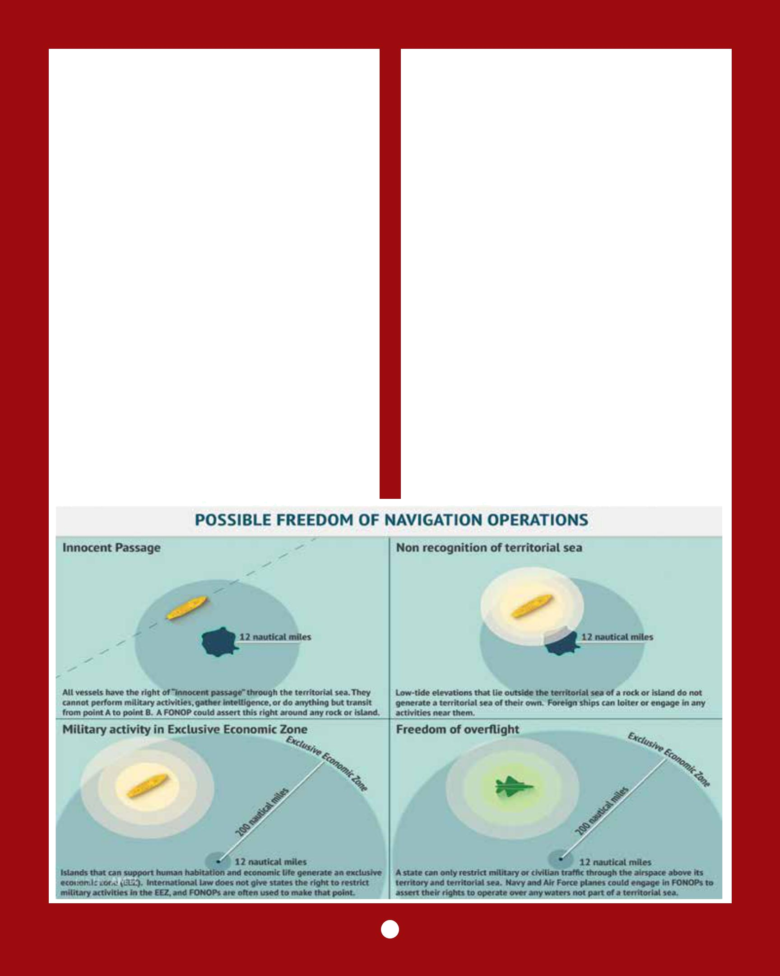
navigated by warships at will. Warships entering waters within 12 nautical miles may do so after giving a simple notice without the need to ask for permission. China’s law requires ships entering its territorial waters within 12 nautical miles to request approval first. The U.S. follows this protocol when navigating near China’s coast, but does not do so in the South China Sea, around Fiery Cross Reef in the Spratly Islands and Triton Island in the Paracel Islands, probably to assert that not all features in the South China Sea are entitled to territorial waters.

Freedom of Navigation Operations in the SCS China has attempted to convey that any international concern about its actions in the South China and their impact on the freedom of navigation is unfounded. China has not interfered with commercial ships transiting the South China Sea, and so there is no ground for concern over the freedom of navigation in the South China Sea. A senior Chinese official, Dr. Jin Kai suggests that the navies might be
confused about the term freedom of navigation and its FON operations. Maritime powers assert that the purpose is to preserve all of the rights, freedoms, and lawful uses of the sea and airspace guaranteed in international law to all states. FON exercises seek to protest what they regard as excessive maritime claims under customary international law.

In October 2015, the USS Lassen sailed within 12 nautical miles of several features in the Spratlys. In January 2016, the USS Curtis Wilbur sailed within 12 nautical miles of Triton Island in the Paracel Islands. In early May 2016, the US Navy staged its third freedom of navigation operation (FONOP) in the South China Sea since China started building artificial islands in the disputed Spratly chain. USS William P. Lawrence, an Arleigh Burke-class guided missile destroyer, sailed within 12 nautical miles of Fiery Cross Reef.

Fiery Cross Reef, as it existed before China’s extensive island-building work, was mostly

6


fully submerged at high tide, with the exception of two rocks. These two rocks may entitle the feature to a 12 nautical mile territorial sea; artificial islands on the other hand do not receive any special consideration. Fiery Cross Reef is among the group of seven features that China has chosen to turn into artificial islands. Fiery Cross Reef has drawn particular scrutiny where China has reclaimed 2,740,000 square meters and has constructed a 3,000 meter airstrip.

China’s reaction to the US FONOP has been to scramble fighter jets, and to deploy ships to shadow the US ship during its passage.

China has expressed the legal argument for a prior notification requirement for warships operating in its EEZ. Drawing a distinction between commercial and military vessels, the Chinese foreign ministry spokesman stated that “no country, except the United States believes in military vessels sailing wherever they want, which is against international law.” The spokesman stated that the U.N. Convention on the Law of the Sea (UNCLOS) “allows innocent passage by foreign vessels through others’ territorial waters, but there is no specific term stating that military vessels have such a right.”

Freedom of Navigation rights are derived primarily from the international law of the sea, as reflected in the United Nations Convention on the Law of the Sea. China’s assertion is that the freedom of navigation consists only of one navigational right. However maritime powers view freedom of navigation is an overarching interest, consisting of a set of rights, freedoms, and lawful uses of the sea and airspace (as codified in UNCLOS). Nations have a number of interests in the oceans such as maintaining peace and security, preserving the freedom of navigation, conserving and utilizing the living resources of the sea, and protecting the marine environment. Tommy T.B. Koh of Singapore served as the conference president
during the last three years of the UNCLOS. He stated in Oct 1982, “I think the Convention is quite clear on this point. Warships do, like other ships, have a right of innocent passage through the territorial sea, and there is no need for warships to acquire prior consent or even notification of the coastal state.”

In December 1982, Ambassador Koh delivered a speech titled ‘A Constitution for the Oceans,’ in which he described a number of interests shared by states around the world. About the freedom of navigation interest, he said, “The world community’s interest in the freedom of navigation will be facilitated by the important compromises on the status of the exclusive economic zone, by the regime of innocent passage through the territorial sea, by the regime of transit passage through straits used for international navigation and by the regime of archipelagic sea lanes passage.” He did not identify freedom of navigation as only one specific navigational right; rather, he described it as an ‘interest’ that was codified by various provisions of the UNCLOS and stated that the treaty’s text “successfully accommodated the competing interests of all nations.”

UNCLOS is comprehensive in scope, its 320 articles balance the interests of all states and address all categories of vessels. A number of those articles recognize specific rights, freedoms, and lawful uses of the seas and airspace that are guaranteed to all states in the oceans of the world. These include: the right of innocent passage through the territorial sea of all coastal states (Art 17), the right of transit passage through straits used for international navigation (Art 38), the right of archipelagic sea lanes passage through the archipelagic waters of archipelagic states (Art 53), the freedoms of navigation and over-flight, laying of submarine cables and pipelines, and ‘other internationally lawful uses of the sea’ in the exclusive economic zone (EEZ) of all coastal states (Art 58), and the freedom of the high

7


seas (Art 87). The text of UNCLOS therefore reflects a number of navigational rights.

International law guarantees rights, freedoms, and lawful uses of the sea and the phrase ‘freedom of the seas’ is accepted to mean ‘all of the rights, freedoms, and lawful uses of the sea and airspace, including for military ships and aircraft, recognized under international law.’ Therefore China’s limited view of freedom of navigation is legally weak and not in consensus with the general understanding of the term. Due to its pressing need to take sovereignty over the vast expanse of the South China Sea, it probably is deliberately attempting to sever the military component of the freedom of navigation interest from UNCLOS. The rights, freedoms, and lawful uses of the sea guaranteed in international law are available to all categories of vessels and aircraft including warships and military aircraft.

UNCLOS sets the parameters on the extent to which a coastal state may enact laws and regulations that restrict the rights, freedoms, and lawful uses of the sea and airspace enjoyed by other states. It requires coastal states to not enact laws and regulations or otherwise take actions that ‘deny’ or ‘impair’ the rights, freedoms, and uses of the sea and airspace guaranteed to other states, and that all of their national laws, regulations, and actions are to be ‘in conformity with’ UNCLOS and ‘not incompatible with’ other rules of international law. For example, Art 24 of UNCLOS states

that, within the territorial sea, a coastal state shall not impose requirements on foreign ships which have the practical effect of denying or impairing the right of innocent passage.

Way Ahead For China

The genesis of the current imbroglio was China’s 2012 decision to give top priority to the South China Sea and initiate an extensive and unprecedented land reclamation program on disputed islands that it occupied or planned to occupy. From a military point of view, US interest in the South China Sea would appear to be to bottle up China’s strategic ambitions as well as its nuclear submarine fleet. It is for this reason that the US FON program escalates a dispute that China would like to limit to a contained and manageable local issue.

To make any headway China’s proposals to settle the SCS disputes would need to strike a balance between its own interests and other countries’ concerns. China will need to establish areas of mutual interest with ASEAN claimant countries and to strengthen areas of cooperation. If China focuses only on pursuing its own interests and disregards the interests and concerns of other countries’, it will give room for the smaller states to turn to outside powers for support and provide opportunities to U.S. and its allies to intervene. This is the real challenge for China of seeing its neighbours relying on China economically but turning to the US for security.

Capt (IN) Ranjit Seth
Senior Fellow, CENJOWS

Centre for Joint Warfare Studies

Kashmir House, Rajaji Marg, New Delhi-110 001 Tel. Nos : 011-23792446, 23006535, 3306538/9, Fax : 011-23792444 Website : http://cenjows.in, e-mail : cenjows@yahoo.com

www.xtremeonline.in # 9311156527

8

