
1

COVID-19

A COUNTER-PANDEMIC STRATEGY

BY

BRIGADIER SANJAY VISHWASRAO
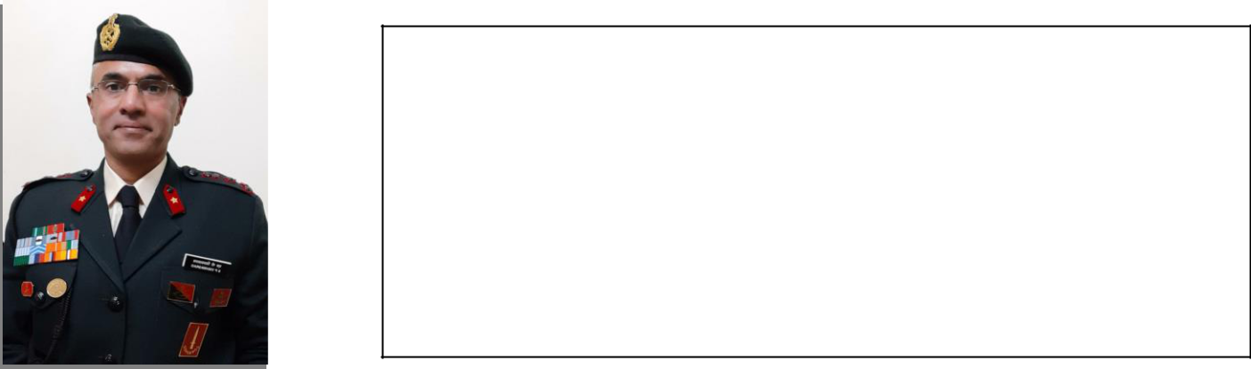

Brigadier Sanjay Vishwasrao was commissioned into 11 RAJ RIF in 1989. He has served in various counter terrorism theatres at all ranks. He has authored Lage Raho Leadership in 2015. He was Defence & Military Advisor in the High Commission of India in Islamabad, Pakistan from 2017 to 2019. The Officer is presently attending the National Defence Course.
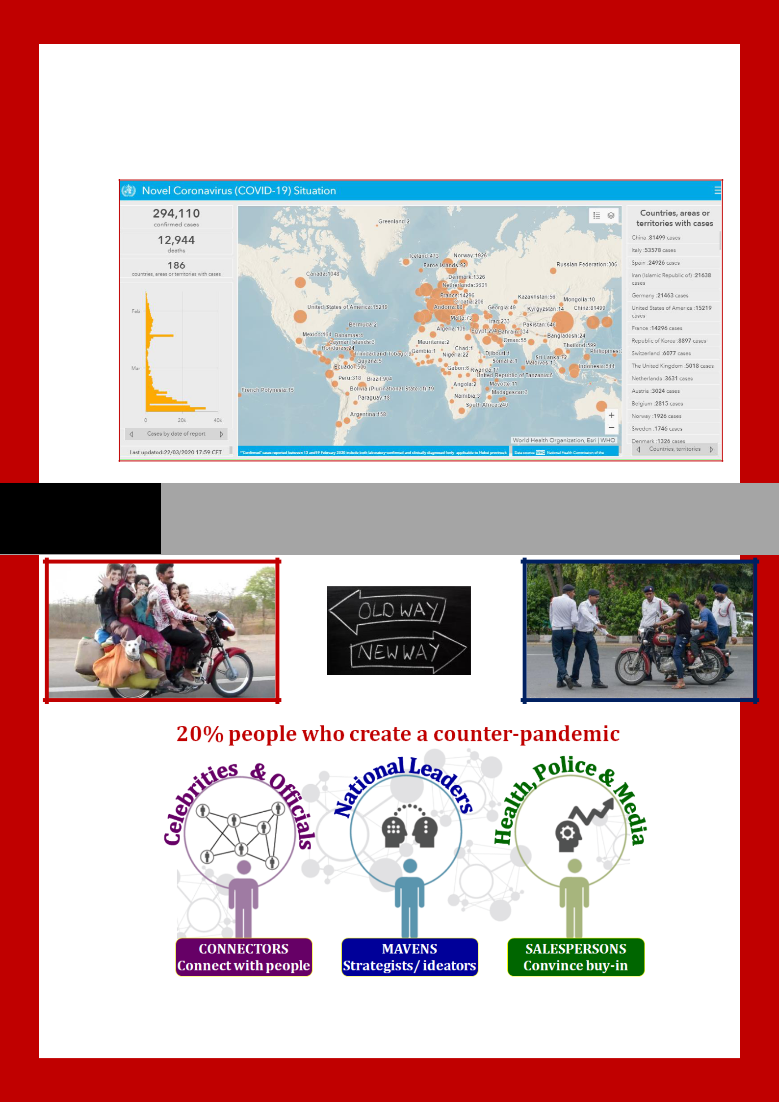
P a g e | 2

COVID-19 A COUNTER-PANDEMIC STRATEGY
P a g e | 3

EXECUTIVE SUMMARY

- Key to defeating a pandemic is a good strategy, just as it is for war. India’s learnings from its HIV counter-epidemic and tips from book ‘Tipping Point’ hold important findings and lessons for combating COVID-19 pandemic. Key ones are:-

- Key Findings.

2.1. India’s unique culture, nationalism, strategic autonomy and Pakistan Strategy of ‘No Terror & Talks’ along with social programmes of Swachh Bharat, International Day of Yoga (IDY), Digital India Programme (DIP) and Make in India (MiI) have helped contain the impact of COVID-19.

2.2. India needs an indigenous COVID-19 Counter-Pandemic Strategy which caters for its economic, technological, social, cultural, demographic and political setting.

- Key Lessons/Recommendations.

3.1. Indigenous strategy to deny/delay the negative tipping point of high number of infected and to hasten positive tipping point of more numbers isolated-treated than numbers infected per day/week/month.

3.2. Isolate India from foreign carriers and focus on affluent 20% carriers with foreign travel history and their family/staff, and 20% counter-pandemic health workers/enforcers to prevent spread to congested susceptible areas.

3.3. Create an environment unfriendly to the spread of COVID-19 (social distancing, Janta Curfew, etc) by using Swachh Bharat, IDY, DIP, etc and repairing roadblocks (slow broadband, no pay for daily wagers, etc).

3.4. Create an environment friendly for the counter-pandemic with easy access to protective equipment, unified payments interface (UPI) based pay/benefit disbursement, imaginative awareness programmes by popular salespersons over all media (especially cell-phone), financial package, etc.

COVID-19: A COUNTER-PANDEMIC STRATEGY
P a g e | 4

Introduction

- Spread of Epidemics/Pandemics. Epidemic is a sudden increase in patients while pandemic is spread of the disease to a larger number of people spread across the world. Epidemics/pandemics occur due to: birth of a new virus/new strain of virus; social conditions favouring its transmission; and social conditions enhancing susceptibility of a society to the virus.1

- Information Technology (IT) in Controlling the COVID-19 Pandemic. IT has a major role to play in responding to a pandemic. GlobalData has reported that cutting edge technologies are at the forefront of the war against COVID-19: artificial intelligence (AI) and machine learning; diagnosis equipment and software; analytics software; sterilisation robots; data processing software for administrative paperwork; mobile telephones with global positioning system (GPS) to track patients; and chatbots/social media for travel/medical/social advisories.2

Developing a Hypothesis: Impact of COVID-19 on India

- Investigation of HIV Epidemic in India. India escaped the HIV epidemic as its society did not accept sexual promiscuity and

homosexuality as a norm, and as travel to/from India was in low volumes, till late 2000s. India has 21,40,000 HIV infected people (3rd rank in the world) which is (Refer Map 13) 0.22% of
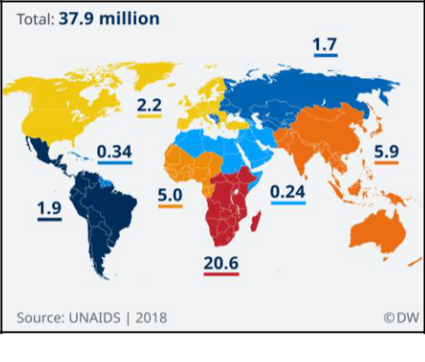

Map 1: Total HIV infected in the World
its 1.3 billion population.4 The reality of HIV epidemic in India is not the 21,40,000 people infected, but the low
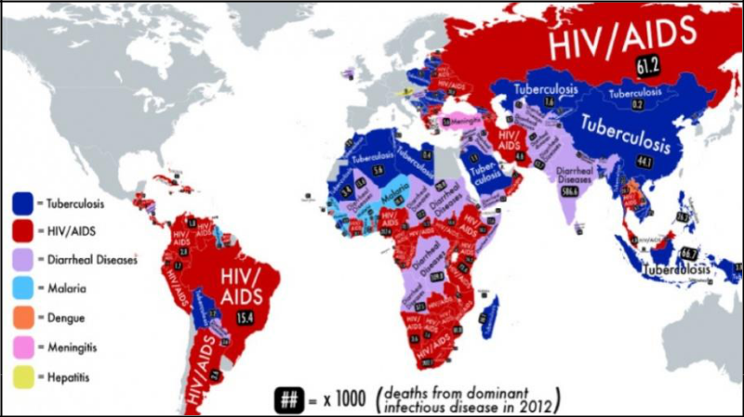
0.22% of population infected. India is ranked 81st in percentage of adult prevalence which is lower

¹https://www.cdc.gov/csels/dsepd/ss1978/lesson1/section11.htmlhttps://www.cdc.gov/csels/dsepd/ss1978/lesson1 /section11.html
- https://www.itnonline.com/article/emerging-technologies-proving-value-chinese-coronavirus-fight

3 |  |  | Map 2: Main disease prevalent in the World
 | https://www.dw.com/en/unaids-report-hiv-related-deaths-down-a-third-since-2010/a-49605119
- https://www.avert.org/professionals/hiv-around-world/asia-pacific/india
P a g e | 5

than the threshold and also adult prevalence in USA and France.5 Refer Map 2.6 AIDS related deaths in India began declining in 2005 (72% decline till 2017) and annual HIV infections have reduced by 85% (compared to 1995) even as tourism picked steam.7 This has vital lessons for India while combating COVID-19.

- Hypothesis. India’s unique culture (Namaste, joint family), nationalism, desire for strategic autonomy and India’s Pakistan Strategy of ‘No Terror & Talks’ along with

Indian Government’s social programmes of Swachh Bharat, International Day of Yoga (IDY), Digital India Programme (DIP) and Make in India (MiI) may have already helped India contain the impact of COVID-19 pandemic. Building upon these may help lower the impact of the current and future pandemics.

Lessons from book ‘Tipping Point’ and India’s HIV Counter-Epidemic

- Lessons from Book ‘Tipping Point’ by Malcolm Gladwell. This book analyses how epidemics spread. Key lessons from this book are:-

5.1. | Tipping | Point.
Tipping point is the point
at which a series of small
changes or |  | incidents
become |  | significant
enough to cause a larger,
more | important change.
In epidemic prevention, it
 |  |  |  | Figure 1: Tipping Point in HIV Epidemic
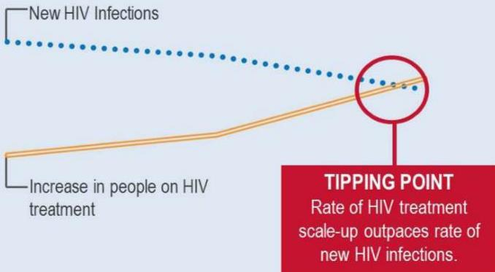

- https://en.wikipedia.org/wiki/List_of_countries_by_HIV/AIDS_adult_prevalence_rate

- https://www.pri.org/stories/2014-10-27/map-shows-which-deadliest-infectious-disease-where-you-livehttps://www.pri.org/stories/2014-10-27/map-shows-which-deadliest-infectious-disease-where-you-live

- http://naco.gov.in/hiv-facts-figures
P a g e | 6

means that the total number of newly infected are less than or equal to the number under treatment. Refer Figure 1.8

5.2. 20:80 Rule. 20% of the people do 80% of spreading of the virus/message, and even work in an organisation.

5.3. Character of Viruses/Messengers. Character/strength of this 20% viruses/infected carriers/messengers dictates virulence of the disease/ message.

5.4. Conducive Environment. Viruses/messages spread when the environment is conducive for them to spread.

- India’s HIV/AIDS Project AVAHAN. It started in 2003 and became the world’s largest HIV prevention programme. Key lessons from it are:-9

6.1. Strategy.

6.1.1. Localised Indian plan as per Indian epidemic patterns.

6.1.2. Business approach mixing project managers, health experts and non-governmental organisations (NGO) helped implement scaled design, not scaling up from a test-bed.

6.1.3. Initial focus was on prevention, not cure; an important strategic decision.

6.1.4. Prevention focussed on female sex workers and their clients, high risk homosexuals and transgenders, and drug injectors in the North Eastern states.

6.1.5. Creating an enabling environment (prevent police harassment, cash transfer over cell phones to sex workers, bathing points for truck drivers, etc) helped encourage the target population to adopt change.

6.1.6. Self-organisation of communities to encourage buy-in and use of partner organisations/projects and NGOs resulted in community mobilisation.

- https://www.ghdonline.org/hiv/discussion/new-px-wire-aids-vaccine-news-and-tipping-point-in/

- https://link.springer.com/article/10.1186/1471-2458-11-S6-S16

P a g e | 7

6.2. Tactics.

6.2.1. Use of peer-led outreach and behavioural change communication helped in spreading key messages.

6.2.2. Easy availability of medical testing and care impeded spread.

6.2.3. Promotion and distribution of condoms and safe drug injections stymied spread.

6.2.4. Regular monitoring and evaluation helped plan interventions for improvements.

- Lessons Learnt from the COVID-19 Pandemic till Date. 7.1. Strategic (Policy).
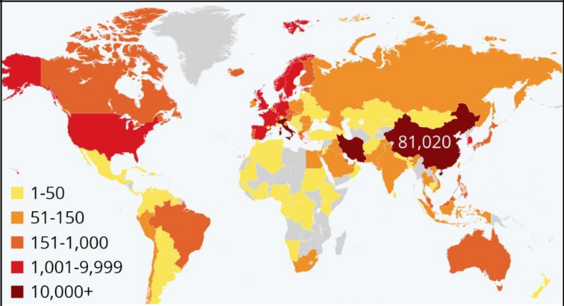
7.1.1. Transmission
in | a | globally
connected world is
fast. See Map 3.10
7.1.2. Pathogens do
not | respect geo- |  | Map 3: Spread of COVID-19 as on 20 Mar 2020

political boundaries, spreading via a common source, by human to human contact or by community transmission.

7.1.3. International religious congregations are fountainheads of epidemics (Chinese New Year, 25 January 202011 and Qom in Iran12).

7.1.4. Governments and societies are not doing enough to prevent animal to human transfer13 requiring acceptance of the concept of ‘One Health’ (health of people closely connected to the health of animals).14

- https://www.newsweek.com/coronavirus-update-new-cases-global-india-italy-california-new-york-1490664

- https://spectator.org/coronavirus-the-price-of-luxury/

- https://www.nytimes.com/2020/02/24/world/middleeast/coronavirus-iran.html

- https://www.thelancet.com/journals/lanplh/article/PIIS2542-5196(20)30035-8/fulltext

- https://www.cdc.gov/onehealth/basics/index.html
P a g e | 8

7.1.5. Delay of two-four weeks in China informing WHO and in WHO declaring a pandemic on 30 January 2020, led to spread outside China, beginning with the 1st case in France on 07 January 2020.15

7.1.6. Delay of one week (02-09 January 2020) in sharing of genetic information of the virus by China. It delayed global collaboration in isolating the virus and finding an anti-virus.16

7.1.7. Inter-dependence with China {with a habit of consuming wild animals from live animal (wet) markets} has affected dependant countries/allies (ASEAN, Italy, Iran and Pakistan). China with its repeated origin of severe acute respiratory syndromes (SARS and COVD-19) and Belt & Road Initiative (BRI) may need to introspect.

7.1.8. The World cannot be un-flattened or de-coupled,17 but transport entry/exit points will have to be strengthened to include permanent medical tests (pragmatic protective globalisation like post 9/11).18

7.1.9. Global cooperation to forecast and defend against new epidemic/disaster needs to improve.

7.2. Tactical (Tools).
 | 7.2.1. The | pandemic
 | curve | can | be
 | flattened by a mix of
 | individual, | social,
 | governmental,
 | business, | NGO | and
 | medical |  | tools/ Graph 1: Flattening the curve in an epidemic/pandemic
 | methods.
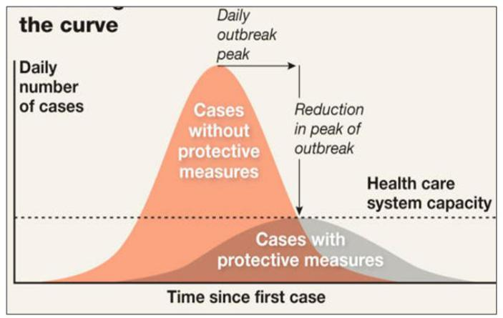

- https://www.aljazeera.com/news/2020/01/china-coronavirus-500-words-200127065154334.html

- https://www.axios.com/timeline-the-early-days-of-chinas-coronavirus-outbreak-and-cover-up-ee65211a-afb6-4641-97b8-353718a5faab.html

- https://theprint.in/world/coronavirus-spread-shows-world-is-still-globalised-former-nsa-top-diplomat-menon/374910/

- https://foreignpolicy.com/2020/03/20/world-order-after-coroanvirus-pandemic/
P a g e | 9

7.2.2. India has been less affected due to lower levels of interactions with China (strategic autonomy and nationalism), early preventive actions by the government (list in next paragraph) and other unique factors. Refer Graphs 219 & 320 for spread in India and other countries.
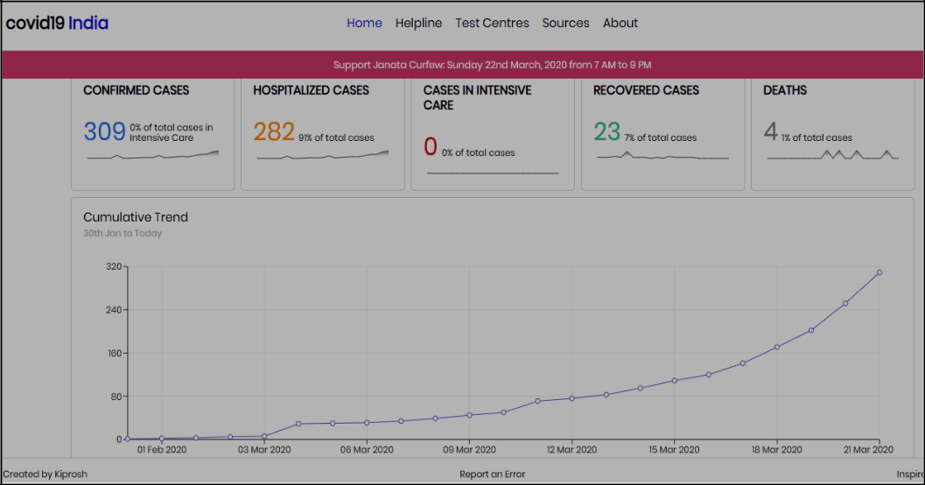

Graph 2: Details of spread in India 01 February to 21 March 2020
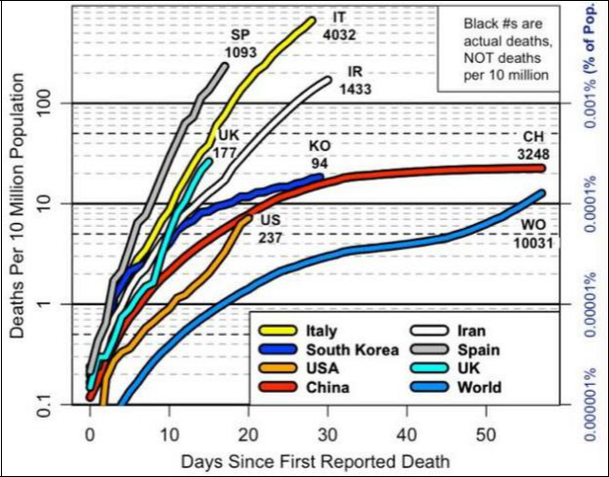

Graph 3: Death per 10 million population till 20 March 2020 in other countries

7.2.3. Unlike HIV in India, affected Indian states/UTs are more prosperous and/or have greater economic/ religious/ tourist connectivity with the World, especially China and early affected countries

- https://covidout.in/

- https://wattsupwiththat.com/daily-coronavirus-covid-19-data-graph-page/

P a g e | 10

(Iran for Shiites, etc). Refer to comparative HIV21 epidemic (2017 estimates) and COVID-1922 pandemic (19 March 2020 data) maps of India below. As for HIV, once again there is a need for an indegenous strategy.
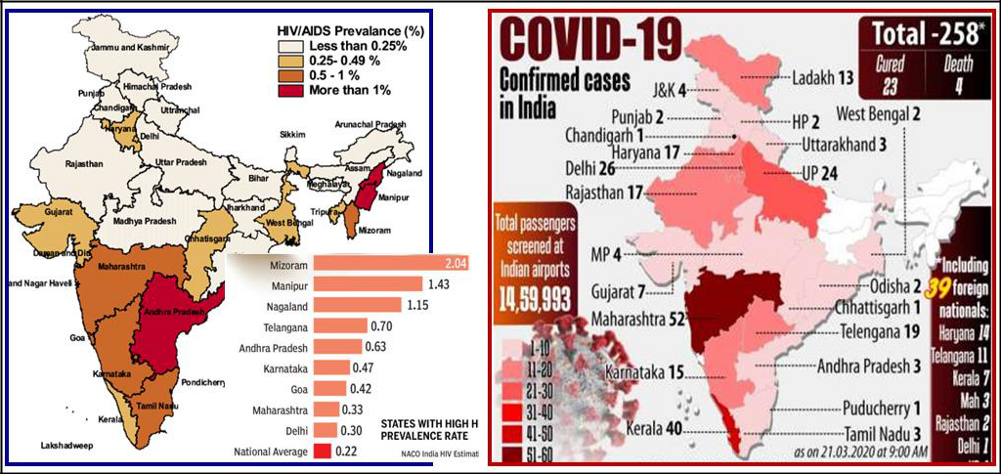

Map 4: Comparative spread of HIV and COVID-19 in India

7.2.4. As it spreads by mingling of people,23 recommended protective measures to delay and
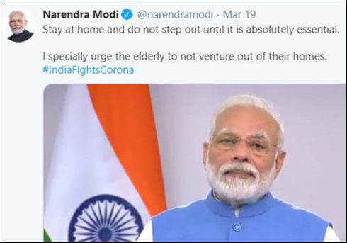

reduce the COVID-19 pandemic peak are: ban on international and local travel personal hygiene;

environmental hygiene; use greeting of

‘namaste’;

Figure 2: PM N Modi’s speech to the nation

on 19 March 2020 for Janta Curfew

- https://timesofindia.indiatimes.com/india/hiv-spread-declining-but-not-all-states-show-progress/articleshow/65816941.cms

- https://www.indiatvnews.com/news/india/coronavirus-india-cases-state-wise-covid-19-list-600081

- https://www.mercurynews.com/2020/03/16/coronavirus-infected-people-without-symptoms-are-driving-epidemics-fast-spread-says-new-study/

- Picture 2: MyGov.in (DIP) certificate for observing Janta Curfew, 22 March 2020

social distancing; self-isolation; self and/or forced quarantine; ban on mass gatherings (schools, work places, religious institutions,
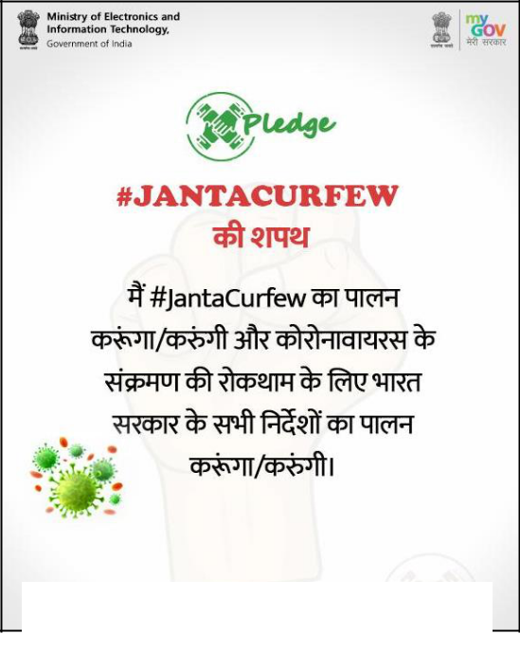
P a g e | 11


Picture 1: A social media campaign for Janta Curfew

etc); and protecting the elderly/sick. All these are part of our unique culture/are being enabled by our unique culture, Swachh Bharat, IDY and DIP. Refer Figure 2 and Pictures 1 & 2.

7.2.5. Self-isolation, Janta Curfew, etc in Indian democray are prone to leakages. Cases of Bollywood celebrity not self-isolating and thus infecting others24, migrant workers trying to board trains in

Pune and Mumbai for home-states25

and celebrations after Janta Curfew in Jaipur, Mysuru, Indore, etc26 hint at

possible requirement of enforcement. This pro-pandemic social

behaviour needs urgent change.

Recommended Strategy for COVID-19 Counter-Pandemic

- https://twitter.com/VasundharaBJP/status/1240953398746157056

- https://mumbaimirror.indiatimes.com/fever-rush/articleshow/74740124.cms

- https://www.firstpost.com/health/coronavirus-outbreak-india-observes-janata-curfew-but-forgets-narendra-modis-most-important-message-of-social-distancing-8176641.html

P a g e | 12

- Immediate Term Strategy. Refer to Graph 4 below.27
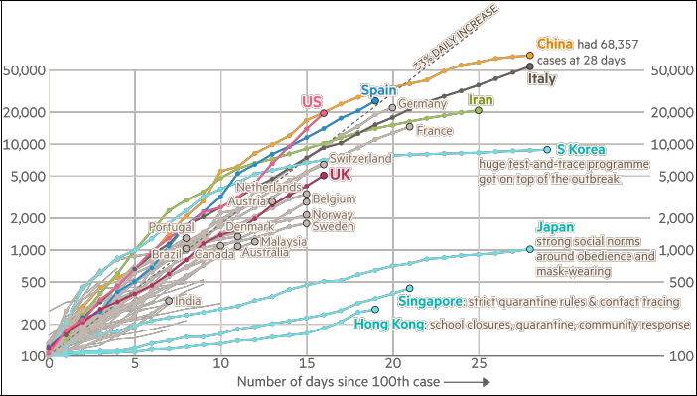

Graph 4: Country comparison of coronavirus case trajectories as on 21 March 2020

8.1. Overall Counter-Pandemic Strategy. The counter-pandemic will spread and overcome the pandemic if:-

8.1.1. Environment. The social environment is made unfriendly for transmission of COVID-19 and friendly for early detection, isolation and treatment. Small, repeated and progressive repairs/changes in the social environment would be required.

8.1.2. 20% Carriers and Warriors. The 20% carriers are identified, isolated and treated early, and the 20% warriors are empowered to ensure this with due personal protection.

8.1.3. Message and Messengers. The correct messages, messengers and media are used repeatedly in catchy ways to spread the counter-pandemic messages so that people voluntarily take actions as required.

8.2. Indigenous Indian Strategy. India needs an indigenous strategy based on isolating-treating 20% carriers in its society, empowering 20% counter-pandemic workers in its society, changing social patterns of spread by its 20%

- https://www.ft.com/coronavirus-latest

P a g e | 13

carriers and changing its social traditions, diet, beliefs, illiteracy, ignorance and indiscipline which facilitate community transmission.

8.3. Stage 1 A, Respond: Prevention of Spread by the 20%. Stage 1 A should focus on preventing spread from overseas travellers/foreigners, as is in progress. It should include use of DIP to identify, track/trace, isolate and monitor cases and their transmission. They are equivalent to the sex workers and truck drivers of our HIV epidemic. Indian citizens arriving/brought back from other countries must be kept in mandatory isolation and thereafter tracked using DIP. Social reporting of defaulters needs to be encouraged.

8.4. Stage 1 B, Respond: Prevention of Community Spread to Congested Population Centres. This should be undertaken simultaneously. Spread to India’s masses living in congested unhygienic urban localities has to be denied/delayed. This is the key to success. The two tipping points have to be attacked simultaneously; negative one denied/delayed and positive one hastened so that we get to the epidemiologist gold ring (70%-80% ‘herd’ immunity due to personal immunity and development of a vaccine) with minimum turbulence.28 This is explained below.

8.4.1. Denying/Delaying the Negative Tipping Point. Refer Graph 5
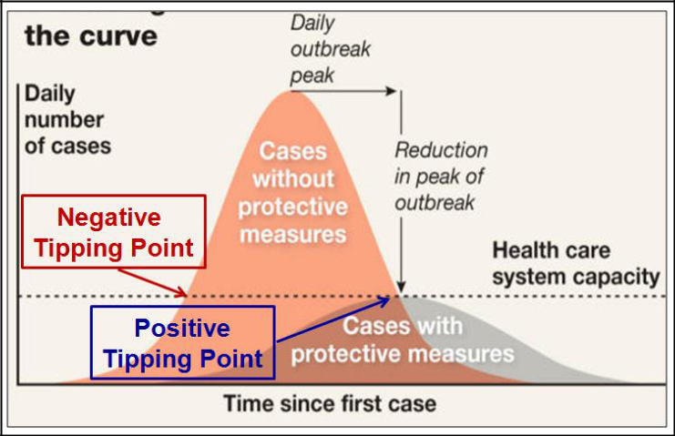

alongside.29 India has to urgently deny/delay this tipping point due to its large population and its poor social hygiene. Additional

measures are:-

Graph 5: Positive and Negative Tipping Points

8.4.1.1. Large Scaled Design. Implement scaled design with synergy between Central and State Governments (health is a state

- https://www.wired.com/story/coronavirus-interview-larry-brilliant-smallpox-epidemiologist/

- https://www.indiatoday.in/india/story/covid-19-coronavirus-can-india-flatten-the-curve-1658213-2020-03-21

P a g e | 14

subject), enforcement agencies, businesses, NGOs and people-group cum individual participation. The rule to follow is ‘better wrong and now, than correct and late’.

8.4.1.2. Beliefs/Traditions. Counter social/religious beliefs and traditions which create environment for community transmission (festivals, mass prayers) and encourage those that deny such an environment (Namaste, joint family, donations).

8.4.1.3. Curfew/Lockdown. National Janta Curfew or enforced lockdown for physical isolation via Section 144 to prevent locality-locality, city-city, city-village and state-state spread.

8.4.1.4. Janta Curfew/Lockdown Enabling Environment. Create an economic and social environment that will support Janta Curfew/Section 144 lockdown and physical distancing using DIP, IDY, Jan Dhan-Aadhaar-Mobile telephone (JAM) Trinity, direct benefit transfer (DBT), ePathshala, SWAYAM, etc. Bottlenecks of no-pay-forced migration of daily wagers back to villages, slow broadband and non-availability of computers preventing work/study-from-home, etc need early resolution.30

8.4.1.5. Urban Population Hubs. These hold the key to controlling the negative tipping point due to difficulties in social distancing and isolation, and of essential services, poverty, illiteracy and ignorance. Identification of employment pattern (working for 20% carriers) and compulsory testing is needed. This may be the weakest link in the counter-pandemic chain.

8.4.2. Hastening Positive Tipping Point. India has to hasten this tipping point i.e., increasing number of people protected/treated than those infected per day/week/month. Additional measures are:-

- https://www.mercurynews.com/2020/03/16/coronavirus-infected-people-without-symptoms-are-driving-epidemics-fast-spread-says-new-study/

P a g e | 15

8.4.2.1. Isolation and Treatment Centres. Create clean-happy facilities in all cities/district headquarters for easy access and to encourage self-admissions. These could be free or paid so as to cater to all categories of citizens.

8.4.2.2. Medical Testing. Large scale medical testing using MiI kits assisted by subsidies/tax relief using DBT and Ayushman Bharat Pradhan Mantri Jan Arogya Yojna (PMJAY) via JAM.

8.4.2.3. Availability of Protective Gear. Easy and cheap access to protective gear as required by various segments/categories of citizens, carriers and warriors. Government offices, businesses, social groups and NGOs can play a role in supply and distribution. GPS tracking by a DIP app may help.

8.4.2.4. Government’s Economic Package. An economic package to businesses, NGOs and individuals to support social distancing, self-isolation and Janta Curfew.

8.4.2.5. Philanthropic Care of Daily Wagers. Encourage those who can afford to support daily wagers/poor with cash, rations, protective gear and medical tests cum care.

8.5. Stage 2, Recovery: Vaccination and Prevention of Re-emergence. Due to a large population and high population density, vaccination and prevention of fresh wave of infections is a must. Additional measures are:-

8.5.1. MiI. Encourage DIP (National Knowledge Network, MeghRaj Cloud) assisted MiI anti-virus solutions for COVID-19 for cheap availability of vaccine and related equipment. Utility of alternatives (yoga/Ayurveda) in combating the pandemic may also be evaluated.

8.5.2. Swachh Bharat. Enforce social change by changing context of ‘chalta hai’. Enforcing traffic, Janta Curfew and municipal hygiene disciplines will help improve taxation discipline and build nationalist ideological unity.
P a g e | 16

8.5.3. DIP. Social distancing, isolation, tracking infected people, MiI and improving traffic, hygiene, Janta Curfew and taxation disciplines are all heavily reliant on IT. This will put additional pressure on each of the nine pillars of DIP. Ministry of Electronics & Information Technology (MeiTy) needs to respond with alacrity and agility.

8.5.4. Medical Information Technology. Develop ability to collect, interpret and exploit data of DIP apps, travel and health histories, etc as inputs in improving the counter-pandemic strategy and manufacturing a vaccine.

- Long-term Strategy.

9.1. Strategic Autonomy. Maintain strategic autonomy in key sectors as learnt from the Asian Financial Crisis of 1997 and COVID-19 pandemic.

9.2. Pakistan Strategy of ‘No Terror & Talks’. With 1/6th the population (213 million) and ½ the population density (287 vs 455 per sq kms), Pakistan had 780 COVID-19 cases (India had 396) as on 22 March 2020.31 Until Pakistan changes its communal and anti-India mindset, and improves its social parameters, it is best to isolate India from its ‘virulence’.

9.3. Evaluate Contribution of Swachh Bharat, IDY, DIP and MiI in

Reducing Impact of COVID-19. contribution of each of these and strengthen India’s national security.

The Government must evaluate the make necessary interventions to further

9.4. Exploit COVID-19 for New Social and Business Norms. Social distancing and Janta Curfew have reduced air pollution32 (air quality index did not drastically improve33) and improved social cohesion. New norms of work-from-home and use of DIP may be monitored-evaluated to strengthen these new environment friendly and nationalist social and business norms.

9.5. Contradictions in Political and Religious Beliefs. Politicisation of illiteracy, ignorance and dogma may have adversely impacted India’s

- https://www.bolnews.com/latest/2020/03/covid19-pakistans-corona-meter-coronavirus-live-update/

- https://www.nytimes.com/interactive/2020/climate/coronavirus-pollution.html

- https://aqicn.org/city/delhi/pusa/m/ and https://twitter.com/parthaabosu/status/1241591584266678272

P a g e | 17

preparedness and response to COVID-19 pandemic which requires social cohesion. Possible contradictions in political/religious beliefs which negatively impact India’s national security may need to be resolved at the earliest.

9.6. International Coalition on ‘One Health’. India may take the lead in promoting this concept and in discouraging food-slaughter of wild animals.

9.7. Global Collaboration on Virus and Pandemic Data. As human population grows, human-animal conflict and transfer of viruses from animals to humans is bound to happen. Thus, another pandemic is assured. The world needs to collaborate for real-time sharing of information on: one, new human-animal conflicts to predict a new virus/pandemic; and two, patterns of new viruses/pandemics to develop a strategy and vaccine.

Conclusion

- COVID-19 has shown how nature-human conflict is not good for any inhabitant of the Earth. It has also shown how interconnected our world is, yet how national characteristics of culture, demographics, politics and economics make each nation, and its relations with other nations unique.

- If during COVID-19 pandemic, India stands out as an example of low impact, it may be due to a pre-pandemic setting of a unique culture and tradition, spirit of nationalism, desire for strategic autonomy and the impact of recent social movements of Swachh Bharat, IDY, DIP and MiI. India can successfully control this pandemic’s curve by an indigenous strategy which creates an environment unfriendly for COVID-

- and friendly for the counter-pandemic. The key is in isolating and treating the 20% affluent carriers by the 20% counter-pandemic warriors, and by protecting our vulnerable congested urban hubs inhabited by uninformed and poor migrant daily wagers till we get to the epidemiologist gold ring. Overall, this pandemic may be an opportunity for Indian society and India.

Disclaimer:- Views expressed are of the author and do not necessarily reflect the views of CENJOWS.

