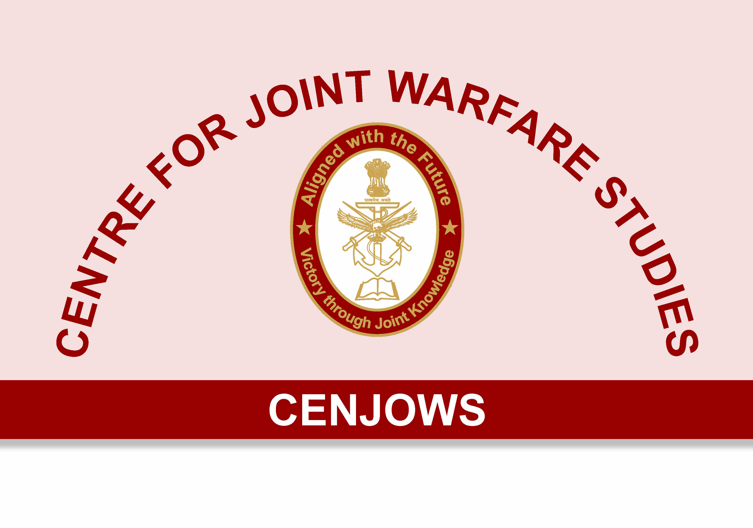
A CASE FOR ELIMINATING PERMANENT COMMISSION AT THE ENTRY LEVEL
By
Rear Admiral Monty Khanna, AVSM, NM
The process for selecting officers for the Indian Armed Forces has evolved considerably over the years. We are now at a stage where the multiple modes of entry may be divided into four broad classes. The three that offer a Permanent Commission (PC) are the cadet entry scheme for 10+2 students, graduate/university entry scheme for graduates and commission worthy scheme which offers an opportunity for promising soldiers, sailors and airmen to join the officer cadre. The last of the four is the Short Service Commission (SSC) scheme which essentially caters for commissioned service of ten years, which may be extended to 14. In a few cases, officers under this scheme may be granted a permanent commission. These numbers are steadily increasing primarily due to growing recourse to judicial intervention. On completion of their mandatory service SSC officers retire without a pension and are entitled to limited ex-serviceman benefits.
With a view to reduce the pension budget of the armed forces as well as to increase the promotion potential of permanent commission officers, the services have endeavoured to increase the proportion of SSC officers. Targets set have yet to be met and the induction agencies are hard pressed trying to find the talent to meet the growing service demands under this category. While there are many aspirants, the ones that fit the bill are difficult to find as often, young boys and girls with the requisite skills do not find this avenue of joining the armed forces attractive enough when compared against their PC brethren. Fully in the know that even if they desire and prove that they are worthy of continued service, their careers are likely to be truncated is a strong disincentive. This is particularly true after the One Rank One Pay (OROP) resolution as well as the seventh pay commission wherein pensionary benefits have been enhanced substantially.
On the other side of the house, there are several talented young people who find the word ‘permanent’ with its implied 20 plus years of unbroken service too daunting to accept. Today’s youth lives in a world of increasing choice, a prerequisite of which is being given the opportunity to bail out should a career choice not meet up to ones expectations. Another pitfall of PC is that having passed one Union Public Service Commission (UPSC) exam and the associated Service Selection Board (SSB), one is assured of a salary/pension for life, irrespective of performance with the odd exception of having committed a major transgression. There is therefore a tendency amongst some to game the system and sail along with minimal contribution. As a consequence of the reasons mentioned above, we in the armed forces are haemorrhaging on multiple counts, which can be traced to the suboptimal in the way in which are induction schemes are configured.
Is there a way to address the issues raised above? A recommended solution is to dispense with PC at the entry level and have SSC as the only avenue. At a certain stage in service, let’s say eight or ten years; officers may be given an opportunity to opt for PC. From amongst those who opt, selection could be made based on service requirements and demonstrated performance. Only those selected will go on to serve till pensionable service and beyond.
What would be the plus side of such an arrangement? There are potentially many. Firstly, it would be administratively much more convenient as in essence, there would be only one scheme for entry into the services with a few nuanced differences. As entry would still be at either the 10+2 or graduate levels, there could be a difference between the mandatory service requirements between the two; say 10 or 12 years for 10+2 and 12 0r 14 years for university graduates. This would cater for the increased investment being made in those who join our academies after 10+2.
Secondly, a shorter commitment at the entry level backed by a clear understanding that there exists a level playing field for all officers, should encourage talented youth to join the services. If the challenges posed do not meet up to their expectations, they are at liberty to leave having completed their mandatory service. An attractive severance package including an opportunity to tailor skills to meet the requirements of the job market by attending a robust resettlement course would make this option palatable. Those who opt to stay do so with a much greater degree of surety as at this stage there are no hidden surprises. Their commitment levels are therefore likely to be much higher.
Thirdly, the era of free lunches will come to an end. There is no doubt that PC with its self-contained assurance of long-term employment and lifetime pension is a major attraction. No longer will those who passed the UPSC exam at an early stage of their life have a free run. As also, no longer will we lose talent from the ranks of extremely capable SSC officers with great potential simply because we don’t have any avenue to hold on to them. The mantra for retention would be ‘demonstrated performance’. If you desire to stay, you have to prove you are worthy of it.
Lastly, from an HR perspective, management of the officer cadre will become much easier. It is difficult to predict what the manpower requirements would be to fill middle and senior level positions in each cadre/sub-cadre at the time of induction. However, eight or ten years downstream, there is more clarity on these numbers. Hence, the number of vacancies on offer in each cadre/sub-cadre could be a powerful tool to ensure that there is the maximum possible alignment between cadre requirements and officers available. This would substantially reduce problems related to over/under subscription in cadres/sub-cadres. It would also result in the evening out of promotion potential for senior ranks in all branches thereby considerably reducing the heartburn that flares up from time to time.
What could be the possible down side if this suggestion were to be implemented? The first is that lacking an assurance of permanent employment at the entry level, we may lose out on talent. This to my mind stems from ingrained insecurity. Which sought after corporate job today offers you an assurance of permanent employment? Yet we find a large number of talented people willing to accept the uncertainty and pursue a career with such entities. The services have a lot to offer. Apart from a handsome salary package and arguably unmatchable perks, it provides the young unique opportunities at character building and acquiring skills which are highly valued in any setting. It encourages you to learn the art of camaraderie and team building under settings that cannot be replicated anywhere. A universal and classless entry scheme will only encourage more people to take the plunge and sign up for a career in the armed forces.
A second possible fear is what would happen if the vast majority choose to leave after completing their mandatory service. Here too, I suspect that the fears are overblown. Permanent commission with the associated pensionary benefits is a very attractive proposition that many if not most would not like to lose out on. The comparison with enlisted personnel where the majority opt to retire after their initial engagement is not an apple-to-apple comparison as they do so with full pension. In any event, if we lose talent in large numbers, possibly in a few sub-cadres, then it will force us to do some introspection and soul-searching to address the root causes of the exodus. Like many other armed forces in the world, we may like to consider giving attractive retention bonuses to sweeten the deal of continued service.
A third possible argument by naysayers could be that when all other government services are offering permanent employment at the entry level, why should we deny ourselves this benefit? Well, we in the armed forces are unique wherein we have a SSC scheme. We expect the commitment of officers who join under this scheme to be as high as those of PC officers. We do not make any distinction in their employability, be it in combat or otherwise. Then why should we make a distinction in their promotion prospects and service conditions? Insofar as the pension budget is concerned, implementation of this recommendation would be cost neutral as the total number of officers accorded pension would remain unchanged. The only distinction would be that the ranks of pensioners will be filled by those with a proven track record.
A final argument could be that every service wants, fully-trained, regular officers, with a long-term commitment to form its core. Other types of entries are essential to supplement this core. The answer to this is that the core will continue to exist as PC officers will come from the ranks of the SSC and will bring along with them all the experience they have gained during the initial 12 to 14 years of their service. The only difference from the way we are currently structured will be that those who constitute the core will not be decided at the entry level, when little is known about the mettle and makeup of a trainee officer, but after he/she has finished at least eight years of service. At this stage, there is adequate clarity on the personality and attributes of the officer to make an informed decision on his/her suitability for retention. In essence we are just delaying the decision as to who forms the core to a time when we can ensure that its ranks are filled by officers with proven capability.

We will not be unique in implementing such a measure. In most nations of the world, a commitment to serve for at least 20 years would be viewed as a strong disincentive and would severely throttle induction. It is therefore not uncommon for the initial period of committed service to lie between five to ten years. As a general rule, the larger the investment made in training, the greater is the period of commitment. Specialized arms such as aviation, submarines and special operations amongst others typically demand longer periods of assured service, but even then, it rarely exceeds eight to ten years. Continued service beyond that is driven by choice and service requirements.
Adopting a universal induction system grounded on a hundred percent SSC force at the entry level would reinforce a sense of fairness in our system that we currently lack. It will help in dissipating the caste system which has crept into our services wherein all officers are equal but PC officers are more equal than others. The perception that SSC officers are there to fill in the base of the pyramid so as to give PC officers a free run towards the apex would end. It would create a climate that is much more conducive to building a strong sense of camaraderie, particularly amongst young officers. It would bring in a sense of meritocracy and encourage all officers to perform to their peak potential as long as they serve. It would be cost neutral and in no way would enhance the revenue budget. Fears of either throttling the flow of volunteers or perpetuating a mass exodus are overblown and stem from unfounded insecurities. It would revolutionize the management of the officer cadre in the armed forces with wide ranging benefits to the organization as well as the individual. With time, we could dispense with the term ‘Short Service’ as it will always carry baggage and replace it with a fresh term like ‘Initial Commissioned Service’ or something akin to it. This proposal deserves to be examined in detail and not shot down by naysayers steeped in the perpetuation of the status quo unless there are clinching arguments to do so!

Disclaimer: Views expressed are of the author and do not necessarily reflect the views of CENJOWS.

